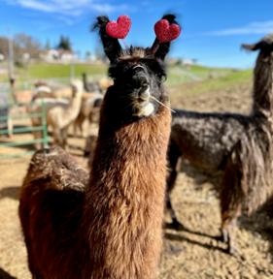  TO DO LIST:  Kathy: respond to email re sale of llamas and alpacas  ALL: re-calendar LANA BOD mtgs from April 20 to Wed. April 19 and from May18 to May 25  Sue: send calendar invites for BOD changes of date  ALL: email Sue with suggestions for mailing application forms to increase 2023 membership  Joy: send 2023 membership fees to organizations to re-up with them  Joy: send Sue the wording to ask about fees incurred by the MAF for funds  Joy: reserve the 8 sites that are close together at the Loafer Equestrian Campground  Sue: prep a show summary form for Joy and email it for posting  Joy & Margaret: work on a Shearing Clinic for Sat. May 6  Joy: create a flyer for the May 6th event | LANA Board of Directors Meeting  February 16, 2023  Minutes
Present: Lee Beringsmith, Margaret Drew, Emily Muirhead, Kathy Nichols, Joy Pedroni, Stephanie Pedroni, Susan Rich, Rondi Smith and Cathy Spalding
Absent:
 | Call to order and review of the agenda: President Kathy called the meeting to order at 6:32. Sue noted an email that had come into the LANA email inbox very recently that would be added to the Secretary’s review of the email. It was also noted that there was an email regarding an artist’s outreach to individual Board members to be discussed in that same spot on the agenda.
Past meeting minutes
Approval of January 2023 minutes: Margaret moved to approve the minutes, and Joy seconded the motion. The motion passed unanimously.
Review of “To Do List”: The list was reviewed and the To Do’s were deemed to have been completed.
Approval of the Annual LANA Meeting minutes: Margaret moved to approve the minutes, and Emily seconded the motion. The motion passed unanimously.
Treasurer’s Report
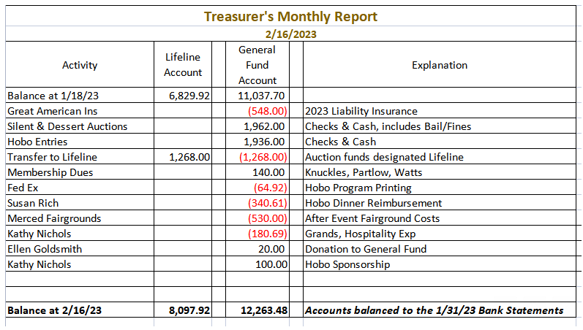
Joy reviewed the expenses as noted in the report emailed to the Board prior to the meeting and provided above. The Board commended Joy for the formatting of the budget report.
Secretary’s Report
- Correspondence: Sue reported on her 27 thank you note cards for both renewal of memberships and for acknowledgement of Hobo Show contributions. She indicated that she has a few more to write for new members.
- LANA email’s inbox: The Board reviewed several emails that came into the LANA inbox, including a recent email regarding advertising of an upcoming llama and alpaca sale (as noted in the revisions to the agenda above). Kathy contacted the RMLA and the Knuckles for information but had not yet heard back. Kathy offered to contact the company tomorrow to find out what the plans were. Kathy
will investigate and let them know about the RMLA, a closer outlet for this particular event. Joy added that she responded to the artist (also noted in the above request for agenda revisions) who emailed us all about her services. Kathy redirected her to a site that would allow her to advertise at no cost. Rondi responded to the artist and indicated she would pass the information on.
- April and May LANA BOD meetings: possible changes? The Board reviewed calendars and rescheduled the April LANA BOD meeting to Wednesday, April 19th and the May Board meeting to Thursday, May 25th. Sue indicated she would send outlook invites to the Board as a reminder.
Hobo Show Debrief
There were 137 entries compared to last year’s 75! It was a lot of fun. Thanks to Margaret for judging and donating her time. The next newsletter will be focused on this.
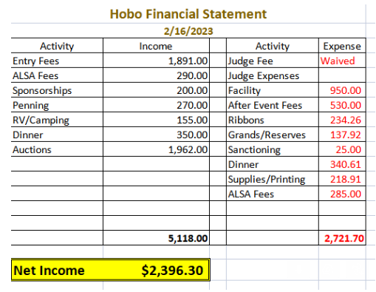
Margaret indicated she wanted to donate the gas money for her trip. Joy shared that we were not charged for some of the items we should have been by the Merced Fairgrounds. So, the after-event fees of $530 were really great.
2023 LANA Membership Drive
- Numbers to date: 21
- Possible outreach re membership: Joy offered to send membership for our 2023 membership to organizations to inspire them to reciprocate. Board members are asked to email Sue with suggestions for mailing an application form to likely 2022 members.
Update on Morris Animal Foundation
- A brief history of LANA and the MAF: Sue reviewed the document she prepared with some background about funding and past research projects.
- Three options presented by MAF: It was noted that the option to fund one last project would take us out of the research business, which is a part of our mission statement.
- Joy had a conversation with Dr. Julie Dechant from UC Davis. GALA (Great Appalachian Llama Project) was provided with the same options from the MAF. Julie is meeting with a group of people to address the void of camelid research from the change of practice with Morris Animal Foundation. Julie would like to form a new protocol for funding. Stephanie added that follow up and accountability of overseeing research are very time consuming. The Board consensus was that we need to investigate options. Joy will be back in touch with Dr. Julie. Joy and Stephanie and Kathy will reach out and plan with Julie. Margaret added that she would like a local flavor for this. Joy will share the date for a face-to-face meeting so anyone wanting to attend may do so.
How can we broaden LANA to North America?
Expanding Social Media outreach: Updates
Emily posted for the first time on Instagram, and the handle was shared via Facebook. The Llama Association of North America – typed out with no spaces and all lower case. She referenced our website with the posting. Emily will be adding info about the Board members and upcoming events. Stephanie volunteered to continue dressing up her llamas for material for future postings.
Newsletter: Kathy shared that she is close to finishing the edition dedicated to the Hobo Show. She is hopeful that it can be uploaded as it is close to 100 pages.
Llamping Plans: We can’t afford to rent out the whole place. So, Joy needs to know how many sites should she reserve. The cost is $45 per night per site, with a limit of 8 people per site. So, the actual cost for the camp reservation is $90 for the weekend per site. Each site has a corral for animals. There are RV slots but no hook ups. Joy will reserve 8 sites and then ask about adding later, if needed. Board decision: $125 for LANA members, and $150 for non-members. Saturday night will feature a communal dinner, the cost of which will be included in the $125 or $150.
Kids & Camelids: April 22, 2023 Tabled Sue will send Joy a Show Summary Sheet for posting.
Continued Discussion of Other Possible Activities/Parking Lot
- YouTube Channel w/ video clips: Tabled
- Fundraising ideas for LAMA Lifeline Tabled
- May Show: Stephanie talked to Eileen and Lisa as reps for SoCal. There are some conflicts in May for members. There is a big sale that won’t be happening next year. She suggests that we put it off for a year because there are so many conflicts.
- Shearing clinic: Margaret volunteered her place for a Joy Sheering Clinic. Might the first weekend in May work for that? On Saturday, May 6? Joy is willing to run it. We can advertise it to the kids at the Kids & Camelids Show. It would be great to get some video of this. Margaret indicated that Ralph can do a clinic on the care of blades and shears. Joy will create a flyer and Joy and Margaret will work on this.
- Other possible events: Demo for skirting a fleece? Tabled
- Community Service Project: American River Clean up – Sept. 16 Tabled
- Felting Clinic Tabled
Request for agenda items for next meeting
- “All of the above”
Date for next conference call meeting:
Next meeting: March 16, 6:30 PM
Future meetings:
Wednesday, April 19 substituted for April 20 & Thursday May 25 substituted for May 18
June 15, July 20, Aug. 17, Sept. 21, Oct. 19, Nov. 16, Dec. 21
Adjournment: President Kathy adjourned the meeting at 8:03 PM.

