Fiber  TO DO LIST:  Sue: revise 9.20.2022 minutes as requested  Joy: reformat LANA Income and Expense Statement as per conversation and send to Kathy and Sue  Sue: eBlast out the revised Statement to LANA members  Kathy: incorporate revised Statement into Hobo program  Sue: revised bylaw wording of section regarding membership and voting/benefits and email to BOD for comment  Stephanie: work on Dec. 9th National Llama Day template for social media use  Emily: work on TikTok and Instagram platforms for LANA  Sue: share youth contest with Nebraska and Rocky Mtn associations  Joy: continue to reach out to Sly Park for reservations  Sue: reach out to K&C participants to finalize dates: either April 22 or 29  ALL: Hold both April 22 and April 29 for the Kids & Camelids Show  ALL: check out the Facebook page for Columbia River Camelid Association | LANA Board of Directors Meeting  October 20, 2022  Minutes
Present: Lee Beringsmith, Margaret Drew, Emily Muirhead, Kathy Nichols, Joy Pedroni, Stephanie Pedroni, and Susan Rich.
Absent: Rondi Smith and Cathy Spalding
 | Call to order and review of the agenda: President Kathy Nichols called the meeting to order at 6:32 PM. The only request for an amendment was Susan’s request to take note of Rondi’s proxy for this meeting.
Past meeting minutes:
Approval of September 20, 2022 minutes: Joy requested amendment to the minutes to remove specific information about the Fiber Clinic. Stephanie moved to accept the revised minutes, and Joy seconded. The motion was approved unanimously.
Review of “To Do List”: Kathy reviewed the To Do List and each BOD member reported on the progress or lack thereof regarding assigned tasks.
Added agenda item: Rondi Smith’s proxy was given to Susan Rich for this meeting.
Treasurer’s Report
Treasurer Joy Pedroni provided the following information in an email to the Board:
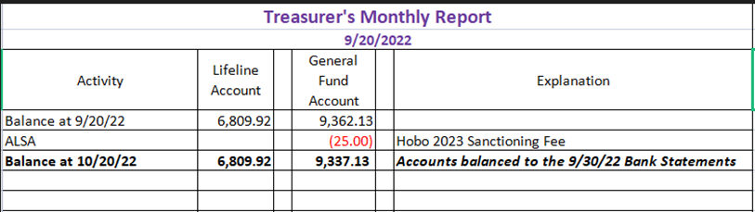
- Joy reviewed the financial table above.
- September 30 is the end of fiscal year, and taxes are due. Joy provided copies of the federal and state forms submitted via email to Board members.
- The BOD also reviewed a new format of end-of-year comparisons from 2021 to 2022 fiscal year (ending Sept. 30 and starting Oct. 1). It was suggested that this be included as part of the Annual Meeting’s program. It was also suggested that we could eBlast this form to membership only, with an option to put any questions to Joy Pedroni. Joy will reformat the report to provide full names for shows and events for those that were shortened for the BOD’s purposes, and provide a few explanations of fiscal amounts to forestall questions.
Secretary’s Report
- Correspondence: None reported
- LANA email’s inbox: None reported
- Bylaw revision work: The LANA BOD continued to work its way through the bylaws in order to have the process completed in time for the Annual Meeting and a vote in late January.
LANA Board Business Tabled
- LANA Elections
- LANA Awards
How can we broaden LANA to North America?
Expanding Social Media outreach: Updates
Template for new social media platforms? Stephanie will work on that. Emily will work on the other platforms of social media.
Youth Writing and Art Contest: deadline Nov. 1
Sue reported that she reminded via eBlast, a specific email to the participants of the Kids & Camelids, and then nudged her own 4Hers about the contest. Kathy is willing to place every submission in the newsletter. The contest allows for an art winner and a writing winner in each of the three age categories of youth. Sue will communicate with Rocky Mountain and Nebraska about their youths’ opportunity to participate.
Newsletter: Kathy reviewed the planned submissions and indicated that this will be a shorter edition of a newsletter, compared to others.
Llamping Plans:
California Plans for 2023: Joy reported that she has reached out several times, and she has not been able to reach anyone
Dates for Kids & Camelids: We are looking at either April 22 and 29. Sue will reach out to participants and ask about which dates work for them.
Continued Discussion of Other Possible Activities/Parking Lot
- Fundraising ideas for LAMA Lifeline: Tabled
- Other possible events: Demo for skirting a fleece? Tabled
- Community Service Project: Lee reported that he has booked Oct. 29th to return to his local library for a llama event.
- Gifts from Linda Rogers Tabled
Request for agenda items for next meeting
- Date for the spring/summer show
- Shearing clinic date
- Elections
- Annual Awards
- Late memberships and the possibility of fees covering more than one year.
Date for next conference call meeting:
Next meeting: Nov 17, 6:30 PM
Future meetings: Dec. 15 Next calendar year?
- Lee suggested that we all check out the Columbia River Camelid Association check out their Facebook page. Lee has reached out to ask about the compliment of imitation.

Adjournment: Kathy adjourned the meeting at 8:27 PM

