Fiber  TO DO LIST:  Sue: notify Joy re the $ amount to move into Lifeline from the Hobo Auction proceeds  Sue: alter the 2025 LANA membership form to reflect the practice of posting a minimum of information on the website  ALL: review the 2024 LANA membership list to look for someone to encourage to re-up  Joy: take the dental appointments for Dr. Mora’s May 11 Dental Clinic  Joy & Margaret: confer to decide if both clinics will be held at Margaret’s  Stephanie: create a flyer for the Herd Health Day  Lee: provide info to be eBlasted out prior to the Buttes event  Sue: in honor of the Year of the Camelid, eBlast out the offer to have folks send in their favorite photo of a camelid | LANA Board of Directors Meeting  February 15, 2024  Minutes
Present: Lee Beringsmith, Margaret Drew, Emily Muirhead, Kathy Nichols, Joy Pedroni, Stephanie Pedroni, Susan Rich, and Rondi Smith.
Absent: Cathy Spalding
 | Call to order and review of the agenda: President Kathy called the meeting to order at 6:33 PM. Lee requested that we add the Butte Hikes to the agenda and Sue requested that we add Year of the Cameilds as well. Later Joy added an item regarding the possibility of some kind of LANA bling that we can share.
Past meeting minutes
Approval of January 17, 2024 minutes: Stephanie moved to approve the minutes as written and Joy seconded the motion. The motion was approved unanimously.
- Review of “To Do List” Board members scanned the to do list in the minutes and noted that almost all of them were in reference to the Hobo Show.
Approval of Annual Meeting minutes: Joy moved to approve the minutes. Emily seconded the motion. The motion passed unanimously.
Treasurer’s Report
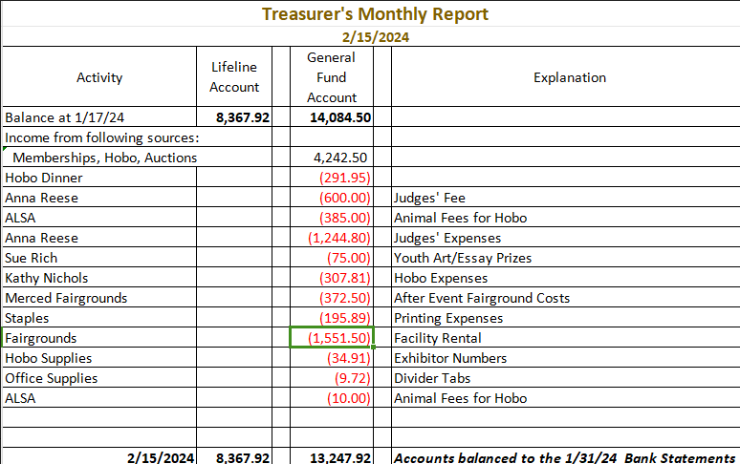
Joy reviewed the budget information above that she had emailed to the Board previous to the start of the meeting.
Secretary’s Report
Correspondence & LANA email’s inbox: Sue reviewed the Secretary’s report that she had sent to the Board earlier, including all thank you notes written for re-upping membership in LANA for 2024 and some noted email activity.
 | Hobo Show Debrief: Joy shared the financials from the Show: $5, 317.50 is the reported income (entry fees, ALSA sponsorships, auctions - even funds that will go to Lifeline-; and expenses totaled $5,389.07 for a loss of just over $71. Some of those expenses are will be spread over several shows and years, so the costs will be amortized. The show really broke even. There were 21 more animals and more
entries this year compared to last year. We had quite a storm that came through. Kathy shared the movement from the wind blown arena to an outdoor area that then got hailed on. The judge just carried on. Joy and Kathy stayed until the bitter end to make sure the grounds were left clean. Sue shared results from the auctions, and we made more this year than ever. Proceeds from the dessert auction, the Lifeline Silent Auction Tables, and the Honey sales will go to Lifeline. Sue will contact Joy to let her know how much to transfer from the General Fund.
Morris Animal Foundation Discussion: Joy shared that an Allison will be contacting Kathy regarding setting up an account with the Wells Fargo for the MAF money. Once the account is set up, Joy will request that the MAF cut a check to that account. She double checked with an accountant to make sure that this money will not cause LANA any tax consequences.
Membership Drive 2024: Kathy had a few questions to ask about listing information about members. Joy is concerned about listing information because of being scammed. The LANA membership form needs to be altered to reflect the practice of what we do and do not post. We can post a website if people what to have that posted. Sue will need to keep this in mind when designing the 2025 form. Sue asked members to please review the list and see if there is anyone they could encourage to sign up.
Discussion with George: March 23rd – Sue just reminded us about the day. There is no new news. She shared the current RSVP list with the Board.
LANA Herd Health Day: May 11
Dental Day with Dr. Mora, DVM @ Margaret’s
Shearing, Toenail, etc. Clinic @ Joy’s
- Appointments for dental work? Margaret shared that the cost will be $85 per llama to have dental work done (this includes the ranch visit fee), and he can do 3 per hour. He will arrive at 9 AM and can probably start at about 9:30. Joy offered to take the appointments.
- Flyer? Maybe photos of animals w/ dental issues would be good to incorporate into the flyer. Perhaps Dr. Mora can provide a before and after. Stephanie offered to create the flyer but asked that someone else provide the photos.
- Stephanie and Joy will have stalls set up at their place. Vans will be available so people don’t have to trailer up the hill. OR perhaps, both clinics can be held at one site. Joy and Margaret will confer on this possibility.
Newsletter: Kathy reported that the Hobo Newsletter is pretty much done. She wants to get Ava’s award to her to include that before the newsletter goes out. The RMLA asked to reprint two articles: Sue’s article on the Not Forgotten Program and Wally Baker’s article on Performance, and both agreed to be reprinted.
How can we broaden LANA to North America?
Expanding Social Media outreach: Updates
- Curated list of YouTube video clips? Kathy felt that we do not need to curate Youtube videos.
- We missed Valentine’s Day for a social media opportunity. Stephanie appreciated that other members have put out some timely photos
Continued Discussion of Other Possible Activities/Parking Lot
- Help to other Llama 4H Projects: Tabled
- Sonoma County Fair: llama presence? Lisa Labendeira contacted Sonoma and she plans to be the superintendent. Sue suggested that we investigate the opportunity to help sponsor the show. Perhaps a versatility award, something similar to what we did for Nationals? Maybe add on to Best of Show or something like that? Perhaps find a really nice ribbon? We can find out if there are any holes that we can fill.
- Added agenda item - Hiking the Buttes: Lee wanted to remind people that Saturday, April 6, is the next slotted opportunity to Hike the Buttes. Taditionally, the group meets at 9:30 at a gas station, and Lee will send something to be eBlasted out.
- Added agenda item - Year of Camelid: Shouldn’t we be doing something? #Year of the Camelid through Facebook. Write an article? Some kind of a photo request of a favorite camelid? Sue can eBlast this out.
- Added agenda item: LANA got a call from someone claiming at the University of Virginia asking about bling. What if we have LANA bling to share? Do we want to find some kind of LANA material to hand out? Maybe something that can be given away at State Fair? Bookmarks?
Request for agenda items for next meeting
- LANA Bling
- Wells Fargo update
- More discussion about Year of the Camelid
Date for next conference call meeting at 6:30 PM:
Next meeting: March 21
2024 meetings: April 18, May 16, June 20, July 18, August 15, Sept. 19, Oct. 17, Nov. 21, Dec. 19
Adjournment: President Kathy adjourned the meeting at 7:28 PM

