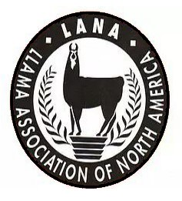
LLAMPING LAKE OROVILLE
June 9-10-11, 2023
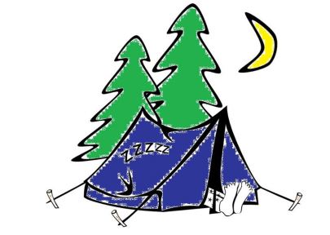
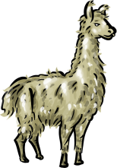

Name: ________________________________________________
Farm/Ranch: ___________________________________________
e-mail: ________________________________________________
Phone: ________________________________________________
Address: _______________________________________________
RV or Tent: ___________
# of Campsites requested: ___________
# of people in your group: ___________ (need for dinner count)
# of llamas in your group: ___________

All Participants must read and sign: It is understood and agreed that LANA, Lake Oroville Loafer Equestrian Campgrounds and their officials, employees and agents shall not be responsible for any loss, damage, or injury to any person, property or animal which is caused directly or indirectly by any reason. The undersigned also agrees to hold harmless LANA and the Lake Oroville Loafer Equestrian Campgrounds for any expense or liabilities including attorney’s fees.

___________________________________________________ ______________________________
Signature Date

I am a current 2023 LANA Member ____

I am a current 2023 FOL Sponsor _____

Payment can be made by check or Paypal through the LANA website at lanainfo.org. Payments must be received prior to the event to hold your campsite for you.

Mail checks to LANA c/o Joy Pedroni, 3966 Estate Dr., Vacaville, CA 95688

