Fibe  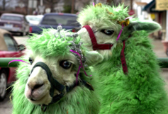  Happy St. Patty’s Day!  TO DO LIST:  Joy: revise the website adding the revised Kids & Camelids flyer and the Show Summary Form, and the NOK card  Margaret: contact Walt Schaff re the cart  Sue: poll the Board for a special meeting re funding research  Joy, Margaret, Steph & Cali: discuss Hobo venue at the SAMVA event  Sue: look into the MJC barn as Hobo venue  Joy, Margaret, Steph & Cali: take photos at the SAMVA event for the newsletter  Lee: get photos of the Butte event for the newsletter  Sue: figure out something using the costumes for the Kids & Camelid Show  Kathy: order the port-a-potty for April 26th’s Kids & Camelids Show  Sue: edit the LANA Youth Award descriptors as per the Board’s discussion and resend  Joy: complete the sponsorship form and send $100 to Nick Hauptly for his show and inquire re the LANA Youth Award | LANA Board of Directors Meeting  March 20, 2025  Minutes
Present: Lee Beringsmith, Margaret Drew, Emily Muirhead, Kathy Nichols, Joy Pedroni, Stephanie Pedroni, Susan Rich, Cali Roberson, and Cathy Spalding
Absent: N/A
 | Call to order and review of the agenda: President Kathy called the meeting or order at 6:35 PM. There were no requests to amend the agenda.
Past meeting minutes
Approval of February 20, 2025 minutes: Lee moved and Cali seconded a motion to approve the minutes as written. There was no discussion, and the motion passed unanimously.
Treasurer’s Report
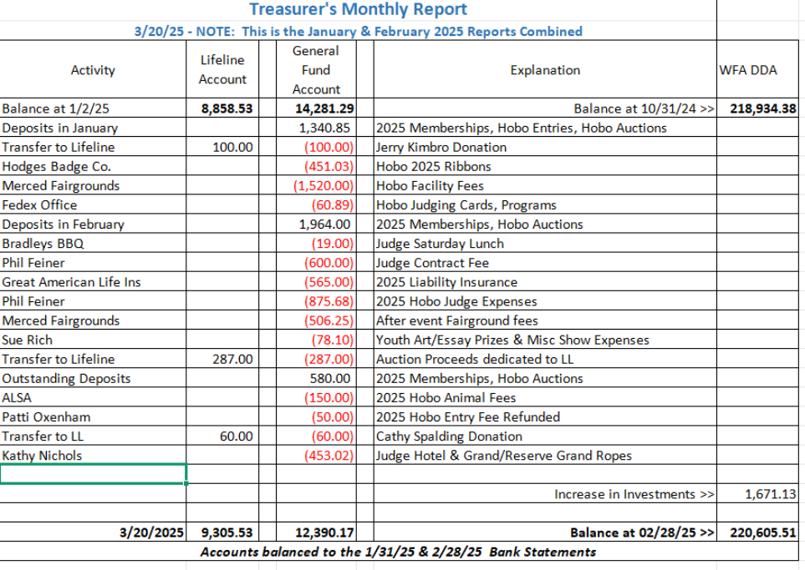
Joy reported that the reduction in the balance from the General Fund was due to losses incurred from the Hobo Show. Note the increase in the invested funds.
LANA Website: Joy plans to take care of the website some time during the next week.
Secretary’s Report
Communication: Sue reported that she had sent a condolence card on behalf of the Board to Becci Kunkle, who works in the ALSA Office, in regard to her husband’s passing.
LANA Notecard update: By next week, Cali believes that she can have a rendition of the “world of llamas” artwork that will available for a small printing before she works on something more creative for a larger print. In the meantime, Sue reported that she had found some inexpensive llama cards that she can use.

2025 Membership Drive:
Memberships to date: 30 Friends of LANA (FOL): 2
Ranch memberships: 27 Club Memberships: 1
Youth Memberships: 3 “Gifted” memberships: 3
Walt Schaff’s cart: Margaret reported that she had emailed Walt but was waiting for a response. She indicated she would try again.
Potential Research Project: Stephanie had provided a summary document for the LANA Board to consider in regard to potential support for camelid research. She covered the document. It was suggested that the Board convene a special session to consider the proposals in depth, which a regular Board meeting does not provide the time to do. Susan will send out potential dates to poll the Board for the best time.
Hobo Show: Potential New Venue: Cali provided a document focused on the Diamond Bar facility prior to the meeting. She and Sue had visited and Cali has had subsequent communication. The pro’s and con’s were discussed, and Cali, Stephanie, Margaret and Joy will continue the discussion in person at the SAVMA event this weekend. It was noted that Diamond Bar is now allowing panels for self-penning. Additionally, Cali briefly discussed her mother’s suggestion – Cali has reservations about this potential second venue because the parking is tight. The facility isn’t used a lot. The owner is a full-time trainer and she might not appreciate having her place tied up for three days. She probably doesn’t have RV hookups. Sue will also investigate the MJC barns just off 99 in Modesto and report back at the next LANA BOD meeting.
SAVMA - March 22 Update: Joy has been planning with Dr. Dechant. There is a limit of 20 vet students. They will arrive at 1:30, and there will be 4 stations: parasite testing (Stephanie); fiber (Margaret), obstacle course and proper handling – leading vs dragging (Cali and the girls); herd health: fighting teeth, trimming, shearing w/o actually providing a shearing demo (Joy and Ron) scoring. Julie will take about nutrition. There will be a feedback form from the students. There will be snack bags and water provided. There is a drawing at the end. Joy thanked the other Board members for their assistance. Kathy requested that someone take pictures. Joy will ask about getting information from the feedback forms.
Hiking the Buttes – Update: Lee reported that the hikers will gather at 9:30, and he hopes to start the hike at 10. It is a large group from UCD. Every year could be the last year for the event.
Kids & Camelids: New date – April 26: Sue shared that she had polled former K&C participants to see if a new date would draw out more youth handlers for the 2025 show. With the feedback, she changed the date of the show from April 12 to April 26. Kathy, Margaret, and Joy are available as “show staff” for both days. Joy asked that we consider doing something with the costumes – maybe a fun race. Kathy is concerned about an injured animal housed near the arena. We can hold it at the very end if time permits, and if it is in the front yard, the injured animal won’t get worked up. Kathy will order the port-a-potty.
Youth Medallions: Sue pieced together a document regarding the LANA Youth Medallion and distributed it to the Board prior to the meeting. The Board discussed the criteria and protocols around the award. Sue will edit the document and reroute it. It was decided that we will consider the award a pilot and pick and choose shows, primarily in California, to start out for a year or two, and then expand if all goes well. We will not post the criteria on the website, but will post the winners from various shows.
- Criteria
- LANA Contact & Protocols
- Informing Show Superintendents
- Support of Specific Shows: The Board discussed sponsorship for Nick Hauptly’s show in Ohio, Kathy suggested $100. Joy moved to sponsor the show for $100. Sue seconded, and the motion passed unanimously. It was decided to include the Youth Medallion if Nick was interested. Joy will reach out.
Newsletter: The spring edition is almost done. It should go out in the next day or two. Kathy will look for articles and photos for the SAMVA event and the Butte hike for the early summer newsletter, due out the second week of June.
Added Agenda Item - State Fair Update: Kathy reported that this year’s theme is: “Times like these” The fairgrounds don’t open until 4 PM for the public on Thursday. Spectators can access the fairgrounds early on Thursday via the Blue Gate. Friday through Sunday, the public gates will open at 10 AM.
LANA BOD Parking Lot Tabled
- LANA’s Vision: how best to serve the camelid community
- Help to other Llama/Alpaca 4H Projects
- Continued discussion re LANA merchandise
Request for agenda items for next meeting:
- SAMVA recap
- Butte Hike recap
- Kids & Camelids update
Date for next conference call meeting at 6:30 PM:
Next meeting: April 17, 2025
Remainder of 2025 meetings: May 15, June 19, July 17, Aug 21, Sept 18, Oct. 16, Nov 20, Dec 18
Adjournment: President Kathy adjourned the meeting at 8:15 PM

