Fiber  TO DO LIST:  Stephanie: scan and send the new member’s application to Susan  Sue: respond to the request for llama experience as per the suggestions  Sue: address the change of address for ALSA when resending the Hobo Show packet  Sue: resend LANA membership forms  Kathy: send Margaret a list of questions for the Herd Health Day for decisions about fees, slots, etc.  Joy: prep the May 11th flyer  ALL: share photos of Hobo w/ Kathy after the show  Kathy, Joy, Stephanie, Sue, Emily: bake for the Dessert Auction!  Margaret: make a basket for the dessert auction  Joy & Cathy: come up with a concise history of the MAF funds for placement in the Hobo Show program and in the newsletter  Sue: connect w/ providers of the Hobo dinner  Emily: check with Mom and Andrew about helping on Friday  Sue: email Joy the amended Annual Meeting agenda for changes and inclusion in the Hobo program  ALL: check out website and give Joy feedback | LANA Board of Directors Meeting  January 17, 2024  Minutes
PRESENT: Lee Beringsmith, Margaret Drew, Kathy Nichols, Joy Pedroni, Stephanie Pedroni, Susan Rich, and Cathy Spalding
ABSENT: Emilly Muirhead and Rondi Smith
Call to order and review of the agenda: Kathy called the meeting to order at 6:33 PM. Susan requested to add “Change of address for ALSA” to the agenda under the Secretary’s Report. Susan suggested that we table everything under the Hobo Show so that it is the last item on the agenda.
Note: Prior to the meeting BOD Director Rondi Smith gave Lee Beringsmith her proxy.
Past meeting minutes
Approval of December 21, 2023 minutes: Sue noted that Joy offered a correction to the minutes prior to the meeting, and Sue read the amended minutes to the Board. Stephanie moved to approve the amended minutes. Margaret seconded the motion. The motion passed unanimously.
Review of “To Do List”: The Board reviewed the list and commented on what had been completed and what had not.
Treasurer’s Report
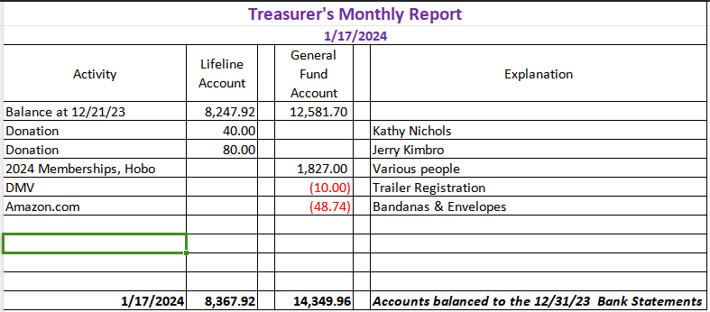
Joy reported that the $1,827 is a combination of 2024 membership, Hobo Show registrations, and some donations. There will be lots of expenses coming in for Hobo in the near future along with additional revenue.
Secretary’s Report
- Correspondence & LANA email’s inbox: Sue reported that she had put 9 thank you notes in the mail for members who re-upped for 2024. Sue solicited suggestions for how to address an email from “Daniel.” It was suggested that she include the mission statement to help clarify what LANA does.
- Change of address for ALSA: Sue reported that she got her ALSA membership form and check back via the Post Office with an “undeliverable” label. Upon checking the website, a new address was listed: POB 850, Decatur, IN 46733 but the membership form on their website continues to list the old Austin, TX address. Sue can include this change of address when she resends the Hobo Show packet.
 | New Year’s Day Hike: Debrief Stephanie reported that Lee, the Pedroni’s, Cali and her girls, and Jana Kane participated. It was a nice walk around the lagoon in
good weather. They drew a crowd while gathering before the hike. There was a New Year’s toast. They encountered a couple who commented that they hadn’t seen llamas there on New Year’s Day in years. Stephanie suggested that we keep this up in the future as a great tradition. Joy added that there was also an old tradition of hiking to a pizza parlor., and this is something we might consider bringing back.
Morris Animal Foundation Discussion: Proposals for placement of funds Joy requested that the agenda item be tabled. Sue shared that she had contacted the MAF representative to let her know that eventually we would be requesting a check to reclaim out funds once we have a location for them. The MAF representative is on hold awaiting that decision.
Sonoma County Fair: Update Tabled.
Membership Drive 2024: Susan reported that there were currently 20 memberships, with 19 of them voting members: 3 Friends of LANA (FOL), 1 youth club, 4 donated memberships, 16 ranch memberships. Sue was asked to eBlast the membership forms again to ensure that the opportunity to re-up didn’t get lost in the holiday shuffle.
Updates on a Discussion with George: March 23rd Sue shared the updated flyer. George would like to provide lunch and wanted a later start time for people who might be driving a distance.
LANA Herd Health Day
Dental Day with Dr. Mora, DVM
Shearing Clinic
- May 11 is secured. How many animals can he see in the day? How much would it cost? In order to prepare a flyer, there are questions that need to be answered.
- To do list: Margaret requested a list of questions that we need to have answers for. Kathy will send that list to Margaret. Once that information is in place, Joy will put together the flyer.
Newsletter Kathy reported that the Winter Newsletter went out. The Hobo Newsletter is formatted, and she can plug in information pretty easily right after the show. She requested photos from people from the show. The Spring edition is also prepped to go and she hopes to get it out around March 20th. Kathy noted that the newest member found LANA on facebook. So, our social media is having an impact.
Hobo Show 2024: Feb. 2-4
- Update on Awards: Chene is working on the Youth Follow Me Award.
- Hobo Village Set up: Friday’s set up is supposed to happen starting at noon in the arena. We can be in the barns all day on Friday. Pedronis will be on site. The Drews will be there as well. She is bringing tables for the auction. Sue will also bring tables.
- Hospitality Table: Kathy indicated that she would prep the coffee pots but whomever got there first could plug them in.
- Auctions: Silent, Lana Lifeline, Dessert Kathy is volunteering to help Margaret at the end of the auction. Margaret thinks she will tape everything down and she won’t need table cloths. Desserts: Joy will bring “Crack,” Margaret will bring a basket of stuff, Stephanie will bring something, Kathy will bring something, and Sue will bring something. Via email, Emily indicated she would bring a dessert.
- Annual Meeting and Dinner: The Board reviewed the draft agenda for the meeting and plugged in presenters, etc. There was extended discussion about the Morris Animal Foundation funds item. Cathy suggested that we provide the history because most of the show attendees won’t know anything about the Morris Animal Foundation. Joy and Cathy will come up with something concise for use in the Hobo Show program and use it as well in the newsletter. Sue will send Joy the draft agenda for the meeting so that she can amend the Treasurer’s Report, if needed, and include it in the Hobo Show program. Dinner – Sue will make arrangements for dinner. Joy will provide Sue with numbers as they come in.
How can we broaden LANA to North America? Tabled
Expanding Social Media outreach: Updates
Curated list of YouTube video clips?
Continued Discussion of Other Possible Activities/Parking Lot Tabled
Help to other Llama 4H Projects
Added agenda item: The website Joy is interested in getting some feedback regarding the website. For $3.99 a month, she can extend our history and future events and really fill it up. She is enthused about this new calendar. Sue moved that we give Joy permission to purchase the extended calendar. Margaret seconded the motion. The motion carried unanimously. The Board is requested to review the website and provide Joy with any feedback.
Request for agenda items for next meeting
- Options for the MAF funds
Date for next conference call meeting at 6:30 PM:
Next meeting: Feb. 15
2024 meetings: March 21, April 18, May 16, June 20, July 18, August 15, Sept. 19, Oct. 17, Nov. 21, Dec. 19
Adjournment: Vice President Stephanie closed the meeting at 8:00 PM

