Fiber  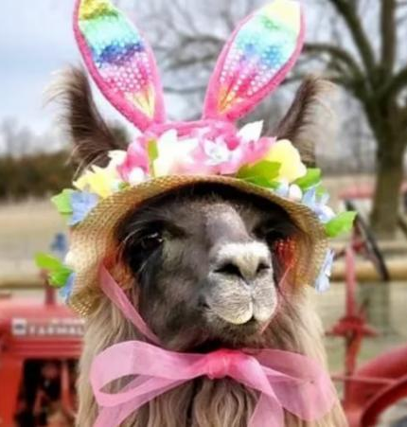  TO DO LIST:  Joy: send flyer for Shearing Clinic to Sue for eBlasting  Sue: send current 2023 LANA Membership to BOD  ALL: review the current list of members and identify 2022 members for outreach, letting the BOD know to whom phone calls or emails may be going  Margaret: create a legend that explains the shorthand notes on the scorecard  Kathy: provide list of each course’s obstacles  Sue: email families of K&C youth about lunch and details of the show  Joy & Stephanie; check out the Oroville facility  Sue: eBlast out a request for mother llamas and crias for a promotion for Mother’s Day | LANA Board of Directors Meeting  April 19, 2023  Minutes
Present: Lee Beringsmith, Margaret Drew, Emily Muirhead, Kathy Nichols, Joy Pedroni, Stephanie Pedroni, Susan Rich, Rondi Smith, and Cathy Spalding
Absent:
 | Call to order and review of the agenda: Vice President Stephanie Pedroni opened the meeting at 6:32. After a review of the agenda, there were no changes. President Kathy assumed facilitation of the meeting at 6:34.
Past meeting minutes
Approval of March 16, 2023 minutes: Stephanie moved to approve the minutes as written. Margaret seconded the motion. The motion passed unanimously.
Review of “To Do List”: There was a quick review of the To Do List.
Treasurer’s Report
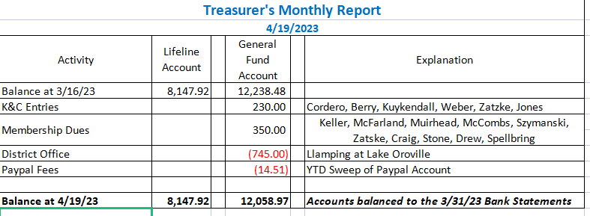
Joy reviewed the Treasurer’s report that she had emailed to the Board earlier and is posted above. There are no outstanding invoices waiting to be paid.
Secretary’s Report
- Correspondence & LANA email’s inbox: Sue shared that she had written notecards and sent stickers to 2023 LANA members who had just re-upped. Additionally, she shared the content of a LANA email eBlast.
- Youth Writing and Art Contest: Sue shared two submissions from junior exhibitors, one an essay and one a piece of artwork for the May 1st contest. The Board was enthusiastic about the idea of rewarding submissions at the different age groups, should the occasion arise.
2023 LANA Membership Drive
- Numbers to date: 31 (w/ new memberships some coming to Kids and Camelids Show)
- Continued discussion about possible outreach re membership: Sue will send out the current 2023 membership list so that BOD members can identify anyone they might want to call. Before doing so, each BOD member will reply to all so no potential members are approached by multiple Board members.
 | Hiking the Buttes Debrief: Lee reported that Stephanie was a prolific photographer. The weather was wonderful, unlike last year when there were 60 mph winds. The rain created some mud down low, but it wasn’t bad at all and there were lots of wildflowers. Dr. Julie DeChant joined the group. They were able to look
at the fort where Fremont camped this year. Altogether there were about 40 participants – the biggest group Lee has ever had. Kathy appreciated the write up and all the photographs for the newsletter.
Kids & Camelids: April 22, 2023
- Registrations to date: 14 official registrants w/3 friends, planning for 20
- Food: Hospitality table + lunch for 55
- Three performance classes
- Interim sessions: The plan is to divide the kids into three groups and in between the official performance classes, send kids to one of three stations: Art session + Thank you note table + Showmanship clinic
- Helpers and help: Scoring table, Art Table, Photographer, Thank you Card Table, Obstacles. There were discussion about whether or not to scribe the judge’s comments. Joy suggested sending the list of the obstacles in each event and the exhibitors’ score cards out after the event. Margaret can include a short- hand list so the kids and their parents can decipher the judge’s notes on scorecards. Kathy will provide the obstacles lists. It was also suggested that we email these out versus including them with the thank you cards and photos via US Mail. Sue will email families with information about lunch. Sue would like to do a great T Shirt with a vote and a prize.
Newsletter: The newsletter went out and it was fabulous. Kathy was commended for her work. The next edition will be Kids & Camelids, and then there will be a summer edition.
Shearing Clinic
Final Date: May 13
Plans: Flyer? Videotaping? Demo? Joy will send the flyer to Sue. Joy would prefer not to video the experience as it is her first Shearing Clinic. There will be multiple stations set up. There will be a booklet about parasites, clippers, etc. This is geared to beginners. There will be hands on experience. Joy will demonstrate on her llama or others, but people can bring one animal to shear. This is a 9 AM – 4 PM event. Margaret indicated lunch would be provided, and that Ralph would be willing to assess people’s equipment: shears, motors and blades. There was some discussion about whether or not to include the “skirting a fleece” demo discussed in the past.
Llamping Plans: Joy paid for sites 1 – 8 at the Lake Oroville facility. A lot of the kids from Miners’ Ravine and the Robersons have indicated they would like to come. We need to start getting registrations. We can mention this at Kids & Camelids. There are pens at each campsite and a variety of trails. There was a concern about water from all the rain. Joy and Stephanie will try to get there ahead of time to check it out. There will be a communal dinner on Saturday.
State Fair: Tracy Weaver is the judge. Entries are not yet open. Kathy will talk to the kids at Kids & Camelids.
Update on funds held by the Morris Animal Foundation: Sue notified the contact at the MAF to let them know that we hope to keep our funds there. There has been no further action.
How can we broaden LANA to North America?
Expanding Social Media outreach: Updates Stephanie was thankful for Sue’s and Emily’s work sharing via email, facebook, and Instagram. Sue will put an eBlast out about Mom and cria photos for the promotion of Mother’s Day. We can create a collage of all the submissions to be blasted out. Our numbers of followers on facebook are increasing and some of them are from different countries. This is part of our mission to promote the species.
Continued Discussion of Other Possible Activities/Parking Lot
- YouTube Channel w/ video clips Tabled
- Other possible events: Demo for skirting a fleece? Included above
- Community Service Project: American River Clean up – Sept. 16. Lee had no real update, except to say that he is thinking about Mile 12.
- Felting Clinic: Tabled
Request for agenda items for next meeting:
- K & C Debrief
- Shearing Clinic Debrief
- Update on Llamping registrations
- State Fair updates
- Membership updates
- Gifts to LANA: the basket panniers + pack
Date for next conference call meeting:
Next meeting: May 25
Future meetings: June 15, July 20, Aug. 17, Sept. 21, Oct. 19, Nov. 16, Dec. 21
Adjournment: President Kathy adjourned the meeting at 7:41 PM

