Fiber  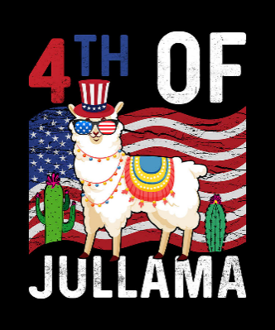  TO DO LIST:  Kathy: forward an address to Sue for a sympathy card if appropriate  Joy: cut the check to pull the newsletter editions back and store in the cloud  ALL at State Fair: help Kathy with obstacle set up on Friday night and take down on Saturday night  Stephanie: prep for the first and last days’ demonstration  Sue: prep the kids for the Friday and Saturday night demonstrations  Sue & Emily: reach out to non-CA llama enthusiasts to create LANA newsletter articles in the form of interviews  Joy: block scammers from LANA’s facebook account  Emily: review Youtube links for all things llama and alpaca and make recommendations for LANA website listing | LANA Board of Directors Meeting  July 20, 2023  Minutes
Present: Lee Beringsmith, Emily Muirhead, Kathy Nichols, Joy Pedroni, Stephanie Pedroni, Susan Rich, and Cathy Spalding
Absent: Margaret Drew and Rondi Smith
 | Call to order and review of the agenda: Kathy called the meeting to order at 6:52 PM. There was a request to add “Driving Clinic” to the list for discussions.
Past meeting minutes
Approval of June 15, 2023 minutes: Stephanie moved to approve the minutes as written, and Lee seconded the motion. The motion was approved unanimously.
Review of “To Do List”: Joy reported that there has never been a requirement for a LANA Lama Lifeline committee member to be a member of LANA.
Treasurer’s Report
This report encompasses May, June and July to date. Joy was able to get the Norton Anti-Virus fee rescinded. It was noted that Llamping event ended in the red because only four of the eight sites we reserved and paid for were used. We will need to advertise this better in the future.
Secretary’s Report
- Correspondence & LANA email’s inbox: Susan reported the correspondence that she had completed since the last LANA Board meeting.
- Deaths in the Camelid Community: Steve Katzakian and Glen Stabelfeld both passed recently. Sue requested an address for the Stabelfeld household.
 | LANA Play Days: Debrief There were 10 attending the first Play Day and 6 people on the second Play Days. The Board discussed whether to continue the Play Days or not. It was suggested that we continue to offer these.
 | Library Llama Day Debrief: Lee, Mike and Jana attended with animals, and there
were approximately 30 kids who came by. Lee made contact with an elementary teacher who requested that he come back to her classroom once school resumed. Kathy reported that she saw a posting on Facebook from the event and indicated it was a phenomenal effort on the library’s part. Lee indicated that there was a vendor selling ice cones as well. Lee believes he will try other county library systems.
Newsletter: The editor of the RMLA is now head of the newsletter network. LANA was invited back into the network with the understanding that permission must be gained from the author of any LANA article that someone else from another publication might want to use. The State Fair newsletter will get out as soon as Kathy can finish it. Late summer newsletter will come out in September. The last edition was sent out as a pdf and that seemed to work well. We will pay a $44 fee (a one-month subscription) to pull the past editions “off their technological shelf” and subsequently store the them in the cloud. Joy will respond to requests to share an old version because they are too big to store on the website. Lee moved to approve the $44 expenditure, and Sue seconded the motion. The motion was unanimously approved.
State Fair: Kathy met with the barn manager. There will be a large number of longhorns in the barn with us due to the addition of mini longhorns. Kathy will have to make changes with the stalling plans. The barn manager will let Kathy know about spaces. Kathy raised the issue of security, and she was told more security is being hired. Entries: 33 more than last year with around the same number of halter entries, 20 for novice in the performance classes, 11 kids total, 29 exhibitors, 206 entries. 53 animals (43 llamas and 10 alpacas). Ellen Goldsmith will help out. Robin will be back this year as gatekeeper. Kathy’s former students will be returning to assist as well. Kathy requests help with watching the public and help to thwart theft. We are allowed to block off the smaller aisles. Once the public is excused, we can use panels at the end of the aisles. The actual fair closes at 11 PM. Try to find ways to block the tack alleys from the public. Take valuable display items with us at night if they can’t be secured. Fishing line can be used to sew things in place. Kathy will need assistance setting up the obstacles after “Walk a llama” event in the ring Friday night, and she will need assistance breaking down the obstacle courses as well. The Skill-a-Thon for youth is yet to be scheduled; Kathy is debating between the first night or the last day. Demonstrations: can adults do the first and last nights and the youth do the two interior nights? Stephanie volunteered to do the first night. Sue will organize the Friday and Saturday night youth demonstrations. Stephanie volunteered to do the last afternoon as well (about 2:30); this is dependent on how the mini longhorns are shown.
How can we broaden LANA to North America?
Expanding Social Media outreach: Updates
- eBlasting show info/clinics for other organizations: we are doing this.
- Writing articles about activities from other states?
4H project from Illinois:
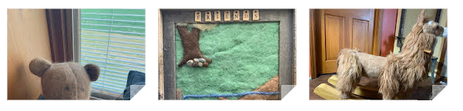
Sue suggested that we could include an article about our members in other states. The Board discussed possibilities. Emily volunteered to do some research about some of those members. Sue offered to send Emily information about members in other states. Sue suggested that we use an interview format rather than ask people to write articles.
- Sharing other camelid organizations’ newsletters? The RMLA newsletter is only accessible to their members.
- Facebook issue: Joy was concerned about scammers using our Facebook posts. We should block them. Joy volunteered to tackle this a little bit at a time.
Request for agenda items for next meeting:
- State Fair debrief
- Fiber Clinic – felting
- Follow up w/ outreach to other states
- Play day – set up a date
- Social Media outreach update (Stephanie commended our recent efforts)
Date for next conference call meeting:
Next meeting: Aug. 17
Future meetings: Sept. 21, Oct. 19, Nov. 16, Dec. 21
Adjournment: President Kathy adjourned the meeting at 7:39 PM.

