Fiber  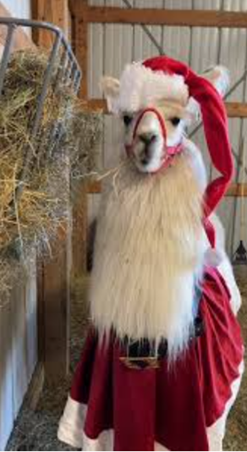  TO DO LIST:  Joy: scan and send 2026 Membership forms to Sue and Kathy  Joy: post Hobo sponsors on website  Sue: schedule eBlasts re Hobo for a series of reminders  Stephanie & Erik: finalize menu for Hobo Dinner  Sue: revise Annual Meeting agenda for Jan. BOD mtg  Kathy: order the name plates for the Annual Meeting awards  Kathy, Cali, and Stephanie: choose a date to visit the Hobo venue to plan  Margaret: make succulent planters for Best of Show for Hobo  Stephanie: continue to work on research possibilities  Sue: re-eBlast about the New Year’s Day Hike  Sue & Cali: finalize a date for Kids & Camelids  Kathy: solicit interest in the Youth Medallion from show superintendents with large youth participation  Kathy: let Sue know to mail her last youth medallion  Stephanie: write up an article for the newsletter about the New Year Day’s Hike and supply photos to Kathy | LANA Board of Directors Meeting  December 18, 2025  Minutes
Present: Margaret Drew, Emily Muirhead, Kathy Nichols, Joy Pedroni, Stephanie Pedroni, Susan Rich, and Cali Roberson
Absent: Lee Beringsmith and Cathy Spalding
 | Call to order and review of the agenda: President Kathy called the meeting to order at 6:33 PM. There were no requests for additions or revisions to the agenda.
Past meeting minutes
Approval of November 20, 2025 minutes: Stephanie moved to approve the minutes as written, and Emily seconded the motion. The motion passed unanimously. There were no reports from the Board’s to do list.
Treasurer’s Report
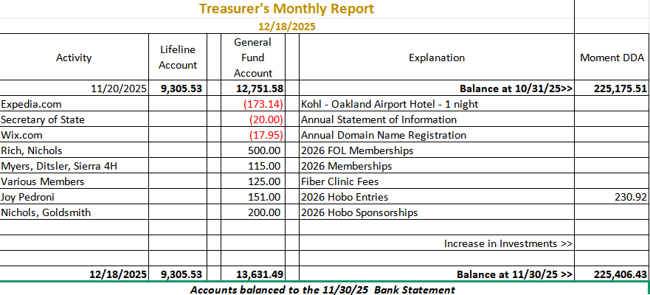
Joy reported the Life Line’s account is exactly the same as it has been for the last couple of months. Joy completed the Annual Statement of Information, and it was filed on time. We had over $1,000 in deposits this month. Investment funds had a modest increase. Joy will send Kathy and Sue updates with each new membership.
LANA Website: Joy archived the Memory Page. She uploaded the reformatted minutes. Joy will put the Hobo sponsors on the website soon in coordination with Kathy.
Secretary’s Report
- Communication:
  - Thank you’s for 2026 membership to Margaret Drew & Tracy Weaver: Sue indicated she has written the thank you notes to include hard copy of the Next of Kin cards along with stickers.
  - Received stash of stickers to continue writing thank you’s: Sue recently purchased stickers so she can continue to thank members.
- Membership Drive 2026: Sue needs information about who has paid for LANA 2026 membership.
- LANA Youth Art & Writing Contest: Sue indicated she has yet to create a cover sheet for future submissions. Kathy has already supplied some wording about single entries – either a piece of art OR a piece of writing.
Hobo Show: 1.30 - 2.1.2026
- Registration and Sponsorship Updates: We have had some very generous sponsors, three of whom are out-of-state. Kathy feels we need to recognize the sponsors more during the show.
- Auction Updates: Sue suggested that she do an eBlast encouraging non-Hobo attendees to US Mail donations to Sue to take to the show.
- Dinner Update: Stephanie reported that Erik is volunteered to be the chef in partnership with his wife. Margaret has volunteered to bring her mac & cheese. More concrete thinking will occur after the holidays.
- Draft Annual Meeting Agenda: Sue reviewed the draft agenda and Board members offered revisions. This will return as an agenda item in January.
- Annual Awards Update: Chene will make the awards. He cannot provide the name plates anymore. Kathy can order them from an out of state source.
- Trip to venue to plan village, etc.: Kathy, Cali and Stephanie will establish a date off line. They will announce the date and other board members can come if possible.
- Friday set up & Stalling: As we have done in the past, Hobo attendees can come on Friday to help and also establish their own stalling areas.
- Weekly blasts re the Hobo Show: auction info, dinner info, safe travels, etc. and directions.
Ribbons and medals have been ordered. Margaret will make succulent planters awards for the Best of Show awards.
Potential Research Projects:
Update on outreach efforts: Stephanie will make contact with the UC Davis rep before Hobo. Stephanie is also in communication with other entities about getting LANA included in the RFP process to start at the onset of 2026. Again, Stephanie will be able to speak to possibilities at the Annual Meeting.
New Years’ Day Hike: Stephanie has had 4 RSVP’s to her flyer about the hike. Cali said she would come with her girls. Stephanie indicated that she would reach out to Lee to ask. If there is rain, Stephanie and Joy will cancel.
Kids & Camelids: Selecting a good date Kathy is open for an event whenever. Whenever it rains, it is very difficult at her ranch. Can we do late April, early May? The last weekend in April and the first in May look good. We will hold those two dates and confer in house. We will have a date for the Annual Meeting.
Board Member Election Results: 20 of the 35 voting members of LANA responded to the email asking for a vote. Both Eileen Ditsler and Margaret Drew were elected and re-elected, respectively, to the LANA Board. Sue indicated she had reached out to both candidates to share the results and to ask the new Board member if the current standing meeting day and time would work for her.
Youth Medallions: Kathy would like to send out emails to show superintendents with large youth participation to see if they might be interested in the Youth Medallion for their shows. For example, Tracy Weaver in Florida, and the Knuckles. Kathy will reach out to Tracy first about an impending show and will report back to Sue to send her last remaining medallion.
Newsletter: Kathy is expecting two articles: one from Dr. Dechant at UCD regarding necropsy and one from the judge from Hobo about his home ranch. She hopes to get the edition out by Jan. 10th. Stephanie will provide an article and photos of the New Year’s Day hike.
LANA BOD Parking Lot Tabled
- LANA’s Vision: how best to serve the camelid community
- Help to other Llama/Alpaca 4H Projects
- Continued discussion re LANA merchandise
Request for agenda items for next meeting
- Hobo Show
- Kids and Camelids
- Research update
- New Year’s Hike
Date for next conference call meeting at 6:30 PM:
Next meeting: January 15, 2026
Continued placement in calendar for 2026: yes.
Future Dates: Feb. 19, March 19, April 16, May 21, June 18, July 16, August 20, September 17, October 15,
November 19, December 17
Adjournment: President Kathy adjourned the meeting at 7:44 PM

