Fiber  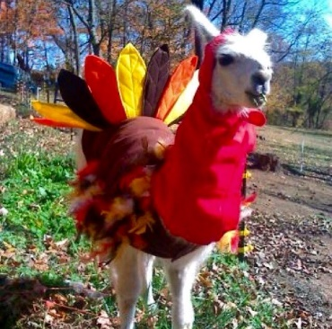  TO DO LIST:  Joy, Stephanie, Kathy and Sue: book Friday, Dec. 8 at Pm for a conference re Morris Animal Foundation and send pertinent contact info to Sue for that event  Sue: re-email 2023 LANA members re Director slots and deadline  Sue: send ballot out on Dec. 1 for vote w/ Dec. 15 deadline  Sue: send updated Youth Contest doc to Joy and Kathy for posting and use  Sue: create a flyer for the “Afternoon with George” event and collaborate with George to complete it  Margaret: confirm May 11 w/ Dr. Mora  Sue: send LANA membership docs to the Board + membership form to Joy for posting  ALL: review membership lists and identify anyone you can reach out to for 2024  Sue: email Nuechterleins about CAians who helped w/ ban on hiking  Margaret: be at the auction tables for Hobo!!  Joy: send photos of Lagoon Valley Park | LANA Board of Directors Meeting  November 16, 2023  Minutes
Present: Lee Beringsmith, Margaret Drew, Kathy Nichols, Joy Pedroni, Stephanie Pedroni, Susan Rich, and Cathy Spalding
Absent: Emily Muirhead and Rondi Smith
 | Call to order and review of the agenda: President Kathy called the meeting to order at: 6:31 PM. Susan requested moving the Morris Animal Foundation from the Parking Lot and putting it and Elections under the Secretary’s report.
Past meeting minutes
Approval of October 19, 2023 minutes: Joy moved to accept the minutes as written. Stephanie seconded the motion. The motion passed unanimously.
Review of “To Do List”: For the most part, the “to do’s” were completed.
Side note: Assignment of proxy from Rondi Smith to Lee Beringsmith as per an email from Rondi prior to the opening of the meeting.
Treasurer’s Report
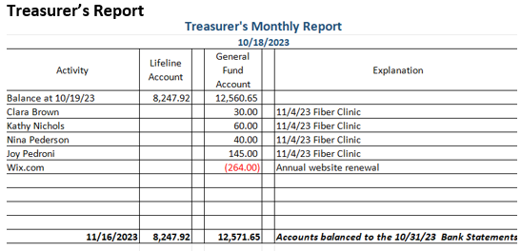
Secretary’s Report
- Correspondence & LANA email’s inbox: Previous to the meeting, Susan sent out a log that included an email exchange regarding an alleged llama abuse case. It was forwarded to the Lifeline contacts. She verbally shared having redirected someone to the ILR who wanted assistance with information about registered animals.
- Morris Animal Foundation conference call: choosing a date. Kathy, Stephanie, Joy and Susan agreed on Friday, December 8th at 1 Pm to meet with MAF staff. Susan will collect phone numbers and emails to forward to the rep at the Morris Animal Foundation. The assumption is that the call will be focused on the LANA funds held by the MAF and any fees that may be charged for their services.
- Elections: Sue will send one more email to LANA members about the Board Directorship opportunity. Stephanie submitted her candidate statement. Ballot at the beginning of Dec. with a Dec. 15th deadline with a response to the LANA email.
 | Youth Art and Writing Awards: Review of updated document: The Board reviewed the newly revised document and made some further changes. Sue will
send the updated version to both Joy (for posting on the website) and Kathy (for use in the newsletter).
Nov. 4’s Felting Clinic - A Debrief: Margaret reported that it was an awesome felting clinic. Several non-members attended. The potluck idea really worked out, and Margaret would be happy to host it again. Because it was held in the barn, any time of the year would work. Perhaps we can incorporate needle felting next time. It is possible to do several types of felting at the same clinic. Margaret has pre-felted pieces ready for use. The Board thanks Margaret for her work and for hosting.
Dental/Shearing Day: May 11 Margaret needs to confirm the date with the vet, Danny. People will need to park at Margaret’s place; her neighbor is gracious about letting her use his property for parking rigs. The first event will be a Dental Day, and then people will be shipped to Joy’s for the shearing portion. There is the possibility of loading llamas into vans as well – a bonus training event.
Prepping for Membership Drive: 2024 Sue will send membership documents to the Board for each member to consider people they might reach out to for 2024 membership. Sue will send Joy the new membership form for posting on the website.
Hobo Show 2024: Feb. 2-4
- Plans to Date: We are trying to entice sponsors. Kathy is considering offering a discount on membership for sponsoring the Hobo Show. Kathy is suggesting that we send out the Hobo packet along with the membership forms so people can make the decisions simultaneously.
- Awards: Sue will email the Alaskan members about who helped with the potential ban on camelids on the trail to ask about members who might have assisted. Youth Award: we discussed that there are lots of youth “coming on.” Joy will make some contacts to retrieve information concerning youth.
- Auction: Joy is the recipient of llama packing gear from Mike Thompson. She does have the discretion to put some things on auction, but he specified that most was to be given away. Joy also has some things from Dolly to bring. Susan has some things from a previous donation as well, including a driving harness. We will have a LANA and a Lifeline and a dessert auction. Margaret offered to run the auction table with her husband. The Board discussed the Buy It Now option and concluded that 1) we must make sure the Buy It Now figure is appropriately high and that someone is at the auction table to monitor that things are not left untagged.
Newsletter: RMLA asked to reprint an article, and Kathy got permission from the author. For the winter newsletter, out around beginning of January, Kathy needs an article from Joy and Stephanie. Stephanie described a screening of the Napolean Dynamite film, and the stars coming early to sign paraphernalia. Afterwards, the actors told stories about the filming, etc. Because there is a llama featured in the film, the theater asked Joy and Stephanie to bring a llama. They were able to set up right by the entrance of the theater. Kathy has an article coming from the Midwest. We will have the election results for the newsletter as well. Sue wondered if we could have a standing feature in newsletter: “How to be smarter than your llama.” Tricks and tips. We could incorporate snippets. We could eBlast out certain questions and incorporate the responses from the field in the newsletter. This was thought to be a good idea.
How can we broaden LANA to North America?
Expanding Social Media outreach: Updates
- Stephanie has been sending out facebook (with large number of sharings) and Instagram. Stephanie will post photos because it is National Hiking Day.
- Curated list of YouTube video clips? Tabled
Continued Discussion of Other Possible Activities/Parking Lot
- Help to other Llama 4H Projects: Tabled
- Morris Animal Foundation meeting: addressed above.
- Lagoon Valley Park: Lee mentioned this was a past practice for a champagne brunch on New Year’s Day.
Request for agenda items for next meeting
- Lagoon Valley Park (by Vacaville) for a New Year’s Day brunch. Joy will send photos of the area
- Hobo Show
- Membership Drive
- Morris Animal Foundation Update
Date for next conference call meeting at 6:30 PM:
Next meeting: Dec. 21
2024 meetings: Jan. 18, Feb. 15, March 21, April 18, May 16, June 20, July 18,
August 15, Sept. 19, Oct. 17, Nov. 21, Dec. 19
Adjournment: President Kathy adjourned the meeting at 7:51 PM

