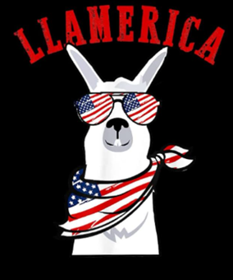 | LANA Board of Directors Meeting  July 23, 2026  Minutes
Present: Eileen Ditsler, Marilyn Drew, Joy Pedroni, Stephanie Pedroni, Susan Rich, and Cali Roberson
Absent: Emily Muirhead, Kathy Nichols, and Cathy Spalding
 | Call to order and review of the agenda: Vice President Stephanie called the meeting to order at 7:01 PM. Joy had the proxy vote for Kathy in her absence. It was determined that we had a quorum.
Past meeting minutes
Approval of June 18, 2026 minutes: Joy moved to approve the minutes as written (with a few typos corrected), and Cali seconded. The motion passed unanimously.
Treasurer’s Report
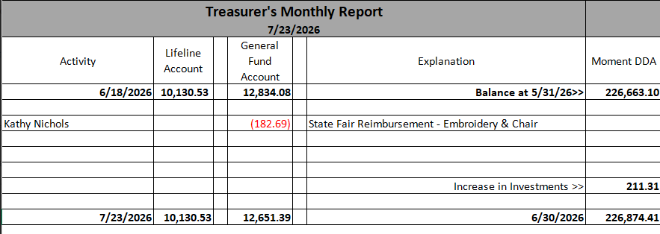
Joy reported that there was very little activity. Kathy submitted receipts for two purchases as noted above. Joy noted that there was a modest gain on our investment. There is a new feature with the bank due to our business status. Joy can reimburse electronically using our check book account numbers. If anyone would prefer checks, please alert Joy as soon as possible. This avoids checks getting lost in the mail or recipients holding on to them for a long time before cashing or depositing them. This will speed up the transactions.
LANA Website: Kathy and Joy went through the website and updated everything. They have a “Come to State Fair” flyer. Stephanie wondered about posting it. It would seem that the Instagram account still needs to be unlocked for LANA access. But the flyer can go on Facebook.
Secretary’s Report
- Communication: Thank you for 2026 membership to Sigrid Riggs
- LANA and Kids Cancer Connection Updates:
  - BOD participants and #’s of animals: It is probably unwise to have older animals up for adoption. Sue will send an email to BOD members asking about
  - LANA’s contributions to “gift bags”: We created a possible list including: llama Stickers, flip note pads, book or card about the specific animal following some sort of a template, a thumb drive w/ a video of the animal, pre-printed llama cards,
Social Media “Campaign” – Caption This Update: The Board believes we have good participation. Sue suggested that we all go through our photos and send potential photos to Kathy so she has a backlog to access for timely posting. We need to include the Instagram option as soon as we can.
Potential Research Projects: Stephanie reported that she is still holding for the next deadline for submission of proposals.
Llamping Dates and Plans: tabled
State Fair: Plans and Discussion
- #’s of exhibitors and animals: The show will be very small this year. We have lost exhibitors for a variety of reasons. Hopefully everything will go smoothly and we will see a return of previous exhibitors. It may also be cooler which could entice exhibitors out again as well.
- Plans for Youth Activities: These will be curtailed as there are only 5 youth. Kathy reviewed the barn with State Fair staff, and she has a barn chart out. Kathy can do walk thru’s with all the age groups at the same time.
- BOD roles and assignments: Kathy will need help setting up and taking down obstacles.
Fiber Clinic Plans
Date(s): Margaret is looking at the possibilities of : latch hooking or “locker” hooking or “Nordic” knitting (one needle knitting). Saturday, August 29th is the chosen date.
Youth Medallions:
- Revised explanation sheet: There was discussion about a young girl whose parents were showing other species who “attached herself like a barnacle” to the llama group, including hours of bathing llamas, etc. Sue reviewed the suggested revisions to the Youth Medallion document that suggest a secret jury, and she pointed out the language that already allows the show superintendent to determine if the winner has to be an exhibitor or not. Margaret agreed that as a judge, it is too difficult to see any behind the scenes behavior of the youth. Sue indicated that she shares the written criteria when she mails a medallion.
- Youth Recipients: Margaret used a “make shift” medallion at a show. The discussion of awardees included the 4 year old mentioned above.
Continued Discussions:
- Show sponsorships – Regionals: There are lot of LANA members who attend. Sue moved to sponsor regionals for $100. Joy seconded the motion. The motion passed unanimously.
- Llama PR Local Opportunities: Stephanie spoke with the cashier at Dixon’s Tractor Supply. She suggested talking to the store manager. Her manager was out on vacation, so Stephanie left some written info and her contact information. Sue suggested school librarians in addition to public library employees.
Newsletter: BOD members will write their stories about getting started with llamas/alpacas for Kathy to have in her files for future newsletters and to expedite the eBlasting of newsletters close to their scheduled debut. In the past, she has been forced to wait for the ranch story to come, and that has slowed down the process. If she can have a back log, she can more easily go to press in a timely way.
Request for agenda items for next meeting:
- State Fair Debrief
- Fiber Clinic Plans, number of attendees, etc.
- Llamping dates
- Update of BOD submission of their stories
- BOD terms – is anyone’s term due to expire?
Date for next conference call meeting at 7 PM:
Next meeting: August 20
Additional meetings in 2026: September 17, October 15, November 19, and December 17

Adjournment: Vice President Stephanie adjourned the meeting at 7:53 PM.

