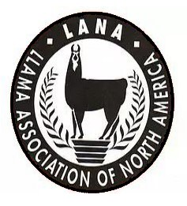
HERD HEALTH CLINIC
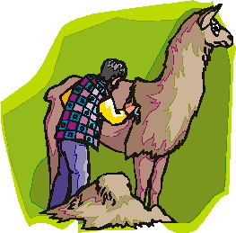
May 11, 2024
9:00 am - 4:00 pm

Name: ________________________________________________
Farm/Ranch: ___________________________________________
e-mail: ________________________________________________
Phone: ________________________________________________
Address: _______________________________________________

I will be bringing ____ llamas/alpacas for the dental treatment. I prefer the time ______.

All Participants must read and sign: It is understood and agreed that LANA and Stonehenge Llama Ranch (Ralph & Margaret Drew) and their officials, employees and agents shall not be responsible for any loss, damage, or injury to any person, property or animal which is caused directly or indirectly by any reason. The undersigned also agrees to hold harmless LANA and Stonehenge Llama Ranch for any expense or liabilities including attorney’s fees.

___________________________________________________ ______________________________
Signature Date

I am a current 2023 LANA Member ____

I am a current 2023 FOL Sponsor _____

