Fiber  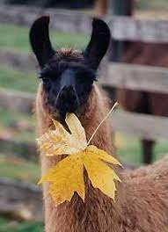  TO DO LIST:  Margaret: send photos of felting to Kathy for Fiber Clinic flyer  Kathy: create the flyer for the Nov. Fiber Clinic and send to Sue and Joy  Sue: reach out to George to discuss the possibility of “An Afternoon with George”  Margaret: reach out to Dr. Mora to talk about the possibility of a Dental Day  ALL: check with our vets (and Lee w/ vet students) about their interest in being included in our eBlasts and email names and email addresses to Sue if they are  ALL: tentatively schedule April 13 for the Kids & Camelids Show  Margaret: forward the contact info to Kathy re the woman selling llama pellets  Emily: begin to curate the You Tubes videos regarding skirting the fleeces of llamas  ALL: gather info re camelid 4H projects across the country for the possibility of zoom conferencing  Sue: connect w/ Never Forgotten CEO and felting 4Hers for newsletter articles  Sue: route LANA Award criteria to Board to start thinking about nominees | LANA Board of Directors Meeting  September 21, 2023  Minutes
 | Present: 100 % of BOD’s present- Lee Beringsmith, Margaret Drew, Emily Muirhead, Kathy Nichols, Joy Pedroni, Stephanie Pedroni, Susan Rich, Rondi Smith, and Cathy Spalding
 | Call to order and review of the agenda: President Kathy convened the meeting at 6:32 PM. There were no requests for revision of the agenda.
Past meeting minutes
Approval of August 17, 2023 minutes: Stephanie moved and Lee seconded to approve the minutes as written. The motion carried unanimously.
Review of “To Do List” – The Board discussed item on the To Do List from the last BOD meeting.
Treasurer’s Report
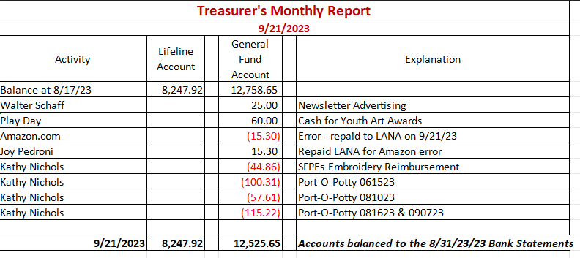
The information above was sent to the Board prior to the meeting.
Secretary’s Report
- Correspondence & LANA email’s inbox: Sue shared that she mailed one thank you card to the Caldwells for 2023 membership. She also reported that she is emailing back and forth with the Not Forgotten Director in hopes of an interview for the newsletter.
- Morris Animal Foundation: upcoming meeting in October – Sue reported that the fund development staff member from the Morris Animal Foundation reached out to schedule a meeting. She is now out on maternity leave, but we plan to schedule that meeting sometime in October when she returns. Kathy, Stephanie and Sue will represent LANA on that call.
 | LANA Play Days Debrief: Four Play Days were held, and the lowest attendance was 7 people, with the highest 17. Stephanie gave Kathy a shout out for her hospitality and hard work for those days. These were excellent opportunities to train and practice with animals.
 | American River Clean Up: Sept. 23 – Lee has been contacted by Cali Roberson and she will be there. Kathy would like to attend, and Stephanie indicated she would be coming as well. Lee indicated there are documents that need to be signed. Lee suggested arriving a little early, by 8:50 at the latest. Stephanie is thinking packs on by 8:50. Lee indicated there is parking designated for livestock
trailers. Lee warned that real caution needs to be used when crossing bike paths, especially with eBikes that travel quietly and quickly.
Felting Clinic: Nov. 4 – Margaret emailed the bullet points for a flyer to the Board. She described Giovana as a real expert in fibers. There will be samples of previous work. There is opportunity for the full range of fiber enthusiasts: beginners to advanced. This will be a potluck. She wants people to bring things that they enjoy making. Margaret will provide breakfast munchies and coffee. She suggested an arrival time of 9 AM with a start time of 10 AM. Weather won’t matter. $40 for non-members, and $30 members. Kathy will put the flyer together once Margaret provides the photos from previous clinics.
Possible event w/ Long Time Llama Enthusiast? – Nina Peterson suggested that George Caldwell is excited about sharing what he knows about llamas. What about an “Afternoon with George” at his place. Sue shared that people could use her place to park cars and carpool to George’s house. Sue will contact George to try to anchor a day. BOD can bring food, like sandwich platter from a store, all pre-made so no one has to make anything.
Dental Day: Tabled Margaret will pursue this.
Prepping for Membership Drive: 2024 – Sue shared a draft flyer for 2024 membership. Lee wondered if we wanted to provide free membership to vets. It was suggested that they can be placed on the eBlast list and receive all our correspondence for free. What about the vet students from the Hike? Lee will reach out and ask his contacts at the Vet School if they would like to get emails. We should reach out to our own vets to see if they might be interested to be eBlasted as well. Sue will take any emails for adding to the eBlast list. Kathy will put something in the fall newsletter as well.
Securing a date for Kids & Camelids: Saturday, April 13? Sue would like to anchor the date for this event. Lee indicated there might be a conflict with the date for the Hiking the Buttes, and the property owners really dictate the date. She has scheduled events that she won’t know yet that may conflict. We have tentatively scheduled Kids & Camelids for April 13th. Joy shared that there might be an additional scorekeeper in play by that time.
Newsletter: Kathy’s newsletter went out a few days ago. A request came in to reprint a couple of articles included. Kathy asked for reciprocal use for one of the articles in the other newsletter. There will be a fall edition that needs to get out to include lots of business: new directors, Hobo advertising, membership, etc. There was a newsletter possibility with Margaret’s acquaintance regarding the use of dirty fiber and creating pellets. Margaret will forward the contact information to Kathy.
How can we broaden LANA to North America?
Expanding Social Media outreach: Updates
- Curated list of YouTube video clips? Emily is still interested. Sue suggested that we look at skirting a fleece as it drops off a llama when choosing what to curate first. This is different than what is done for alpacas. Margaret indicated that she is willing to host something about this during shearing season. Joy indicated we could combine this with a shearing clinic.
- Newsletter articles: having articles from various parts of the country will assist this “reach” as well. We still have two ideas out there – one about the 4Her doing the felting work and the other the Not Forgotten use of a llama with vets.
Continued Discussion of Other Possible Activities/Parking Lot
- Help to other Llama 4H Projects: Joy has not yet chatted with leaders of the different 4H leaders.
- Sue suggested that we might be utilize zoom or Teams to have niche meetings with people from all over the country. 4H groups? Obstacle designers? Kathy said she could look for lists of camelid 4H projects and Rondi suggested that we could also reach out to Organizations with connections.
Request for agenda items for next meeting:
- Report back on 4H camelid clubs
- Debrief of American River Clean Up
- Update of conversation with George
- Youth Contests for Writing and Art
- Hobo Show
- LANA Awards (recirculate the awards criteria)
- Resurrection of the Youth medallions at shows
Date for next conference call meeting:
Next meeting: Oct. 19
Future meetings: Nov. 16, Dec. 21
Adjournment: President Kathy adjourned the meeting at 7:48 PM

