Fiber  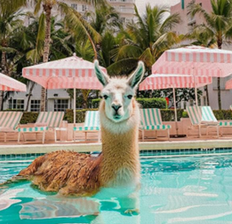 | LANA Board of Directors Meeting  June 19, 2025  Minutes
Present: Lee Beringsmith, Margaret Drew, Kathy Nichols, Joy Pedroni, Stephanie Pedroni, and Cali Roberson
Absent: Emily Muirhead, Susan Rich, and Cathy Spalding
Call to order and review of the agenda: President Kathy opened the meeting and requested that an agenda item be added: the donations from Linda Rodgers.
Past meeting minutes
Approval of May 15, 2025 minutes: Cali moved to approve the minutes as written, and Margaret seconded the motion; the motion passed unanimously.
Treasurer’s Report
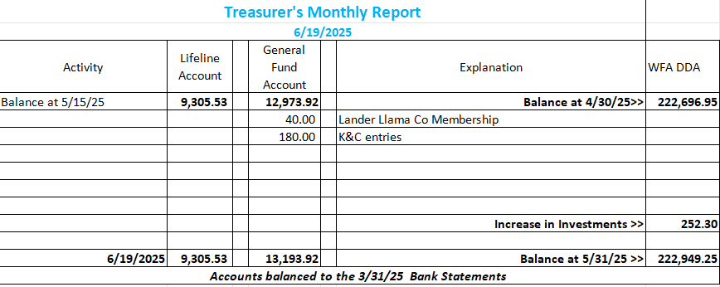
LANA Website: Joy reported that she had updated some of the website but not all of it.
Secretary’s Report: Tabled in Sue’s absence
- Communication: 2 thank you’s for 2025 membership
- LANA Notecard & NOK card updates: Copies are in hand
2025 Membership Drive: Tabled in Sue’s absence
Memberships to date: 36 Friends of LANA (FOL): 2
Ranch memberships: 32 Club Memberships: 1
Youth Memberships: 3 “Gifted” memberships: 5
Potential Research Project – Updates Tabled as per Stephanie’s request
Hobo Show: Potential New Venue Joy reported that the Rolling Hills venue would be too expensive.
Added agenda item: Linda Rodgers’ donations to LANA Kathy reported that she had picked up all of Linda Rodgers’ donations to LANA from Jerry Kimbro. She will go through and determine what might go to the next Hobo Show auction table.
Kids & Camelids Debrief In Sue’s absence, the debrief was brief. Those present reported that overall, it was successful. There were some first-time show-ers in the group and some first timers to the Kids & Camelids Show.
Youth Medallions
- Update: Joy indicated that she needed to look at the pricing
- Ordering new medallions: We have just a few left, and we need to order more.
State Fair Updates: Kathy reported that the window to register for the show closed on June 18th, but she has not yet seen the numbers. She did hear that someone who had shown 15 – 20 years ago or so was coming back.
Newsletter: The early summer edition looked great!
LANA BOD Parking Lot
- Walt Schaff’s Cart: Margaret has not yet heard from Walt about the cart. Kathy will try to reach him as well.
- LANA’s Vision: how best to serve the camelid community: Lee reported that he is attending a Yuba City Library event in a few weeks, and anyone is welcome to attend. He highly encouraged others to reach out to their local libraries to do the same.
- Help to other Llama/Alpaca 4H Projects: Jocelyn Katzakian is planning to take over the Llama 4H group that her Dad, Steve, had headed up. LANA should reach out to determine if we can be of support.
- Continued discussion re LANA merchandise
Request for agenda items for next meeting
- State Fair prep
- Research options
Date for next conference call meeting at 6:30 PM:
Next meeting: July 17
Remainder of 2025 meetings: Aug 21, Sept 18, Oct. 16, Nov 20, Dec 18
Adjournment: President Kathy adjourned the meeting at approximately 7 PM.

