Fibe  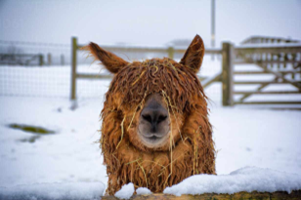  TO DO LIST:  ALL: Try to help set up the Hobo Village on Friday, Jan. 27th at the Merced Fairgrounds  Stephanie: email photos of Hobo Village set-up to Joy  Joy: print photos & bring to Hobo  Margaret: send Sue a photo of the llama carving  Sue: post the final on-line auction opportunity to bid  ALL: bring auction items to Hobo w/ bidding slips prepped  Kathy: bring auction bid sheets to show for donors  Kathy, Stephanie, Margaret & Sue: bake/buy desserts to bring & fill out dessert slips for auction  Sue: send revised Annual Meeting agenda to Joy for inclusion in the Hobo program  Kathy: ID presenters of LANA Awards for Meeting agenda and let Joy know  Joy: prep Hobo program to include: FOL sheets, LANA budget summary, agenda for Annual Meeting, etc.  Sue: send bylaw out to 2023 LANA members for voting by proxy for non-Hobo attendees  Stephanie & Margaret: design a one page “ad” and get to Joy for Hobo program  Sue: send 2023 LANA application forms as requested  Sue: create Valentines eBlast and send to Emily and Steph or other platform use  Joy: con’t to reach out to secure Sly Park dates for Llamping trip | LANA Board of Directors Meeting  January 19, 2023  Minutes
Present: Lee Beringsmith, Margaret Drew, Emily Muirhead, Kathy Nichols, Joy Pedroni, Stephanie Pedroni, Susan Rich, and Cathy Spalding
Absent: Rondi Smith
 | Call to order and review of the agenda: President Kathy called the meeting to order at 6:31 PM. She noted that we needed to start the meeting with an election of officers to start out the year. Susan noted that we needed to acknowledge the re-election of Margaret to a three-year term. These agenda items were added.
Added agenda item - Officer Election:
Joy moved to re-elect all existing officers into the same positions again for next year. Lee seconded the motion. The motion carried unanimously. The LANA officers for the calendar year 2023 are as follows:
President: Kathy Nichols
Vice President: Stephanie Pedroni
Treasurer: Joy Pedroni
Secretary: Susan Rich
 | Added agenda item - Recognize new three-year terms for Lee and Margaret: This agenda item recognizes that Margaret Drew was elected to a three-year term by the established quorum of 16 votes, all unanimously in favor of her candidacy. Lee was appointed by the Board during the December meeting.
Past meeting minutes
Approval of December 15, 2022 minutes: Joy moved to approve the minutes as written. Margaret seconded the motion. The motion passed unanimously.
Review of “To Do List” It was noted that the items on the To Do List were on the agenda for discussion.
Treasurer’s Report: Joy supplied the Treasurer’s report via email prior to the meeting and reviewed during the meeting.
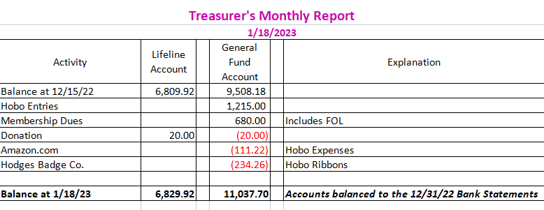
Secretary’s Report
- Correspondence: Sue reported on the thank you cards mailed for 2023 membership submissions, and she shared she had US Mailed some application forms to 2022 a handful of 2022 members.
- LANA email’s inbox: Sue shared some emails from previous members with concerns about exposure at shows for breeders.
Hobo Show
- Updates & discussion
  - Current # of registrants: So far registrations include 11 ranches (with 2 more expected). There are 31 expected for dinner. There were a total of 74 entries last year and so far this year we have 120 entries with 49 animals in attendance.
  - Work details for show: While we can arrive in the morning on Friday, 1.17.2023 to put in our animals and set up our pens, the set up time in the actual arena is from 12-4:30 PM. Ellen Goldsmith will be in attendance to help with set up and obstacles. Sue indicated that she will be bringing Robin and Andrew Muirhead with her to assist. Stephanie will send photos from last year to Joy and Joy will bring them as a guide to setting up the Hobo Village. We have all day on Sunday to clean up and exit the barns and arena.
- Auctions:
  - Pre-show eBlast Auction participation: Susan described the current experiment with an on-line options to bid on certain items. The first item had 3 show attendees willing to pay the Buy It Now price. The third item was a Buy It Now purchase by a show attendee. There will be a 4th and final “Auction from afar” opportunity with a llama carving that Margaret is donating. Margaret will send Sue a photo of a carving. Margaret suggested a minimum bid of $200 with a Buy it Now price of $250. She also suggested that we send out teasers for the show auction about what will be there and encourage people to contact their friends who might attend.
  - Silent auction - LANA & Lifeline tables: Board members who are bringing auction items were asked to have their slips filled out ahead of time. Kathy will be bringing paper copies for the auction items.
  - Dessert auction: Kathy will bring her apple cake, Stephanie and Joy will be bringing desserts, Emily will bring something, Margaret will bring her famous lemon pie, and Sue will bring things as well. Susan asked people to come with dessert tags filled out.
- Annual Meeting & Dinner
  - Annual meeting agenda: The Board considered the draft agenda provided and refined it.
  - LANA Awards: Kathy indicated she would reach out to identify presenters for the LANA awards.
  - Added agenda item - Dinner: Sue will call in the order, make payment, and pick up the meal. Kathy will email Sue the name of the caterer.
  - Program: Sue will send Joy the revised Annual Meeting agenda for her to complete and include in the program, along with her one pager for the FOL page. Stephanie will design and send Joy an ad for her. Margaret gets a full-page ad in the program as well.
2023 LANA Membership Drive
- Numbers to date: with the one additional new member Joy announced, we have currently 16 members:
  - 12 returning, 3 new, 3 FOL, 1 youth, and one 1 youth club
- Outreach re interests of membership: The Board briefly discussed any 2022 members who might appreciate receiving a hard copy application.
How can we broaden LANA to North America?
Expanding Social Media outreach: Updates
- Dec. 9: National Llama Day Tabled
- Rocky Mountain’s emailed holiday messages. Susan will send whatever eBlast message she creates to Stephanie and Emily regarding Valentine’s Day for sharing on other platforms. We can do this for any holidays. We could put together a calendar of dressed up llamas representing the newsletter.
- New idea: We could talk to people about how to expand LANA’s reach to North America at the Hobo Show.
Newsletter: Kathy thanked Sue and her 4Hers for their articles and photos for the Winter edition. Kathy asked that Board members take photos behind the scenes and email them to Kathy. If anyone has an idea for articles or if we have an idea for a repeat article, let Kathy know. Joy was able to put the newsletter on Facebook, and it gets shared. This is expanding our reach. Kathy has been posting photos through the memory feature of her iPhone on Facebook, and we can repost on our own facebook accounts to spread the word even more.
Llamping Plans:
California Plans for 2023: Joy is still trying to secure the second weekend in June for the Sly Park facilities. We have nothing reserved thus far. Joy will continue to reach out for them.
Kids & Camelids: April 22, 2023 Kathy talked to Sabina and her 4H group is planning to attend.
Continued Discussion of Other Possible Activities/Parking Lot
- Fundraising ideas for LAMA Lifeline Tabled
- Other possible events: Demo for skirting a fleece? Tabled
- Community Service Project: American River Clean up – Sept. 16 Tabled
- Felting Clinic - Margaret offered up some new ideas for a clinic: fiber painting, needle felting, etc.
- YouTube Channel w/ video clips Tabled
Request for agenda items for next meeting
- Hobo wrap up (we can have an hour mtg dedicated to just Hobo after Hobo and prior to the Board meeting)
- Buttes Hike
- Kids & Camelids
- Felting Clinic – to establish dates: spring, fall?
- Spring Fling Show
- Tik Tok – Hobo posting
Date for next conference call meeting:
Next meeting: Feb. 16, 2023, 6:30 PM
Future meetings: March 16, April 20 & May 18 (Sue has conflicts for both), June 15, July 20, Aug. 17, Sept. 21,
Oct. 19, Nov. 16, Dec. 21
Adjournment: President Kathy adjourned the meeting at 7:55 PM.

