Fiber  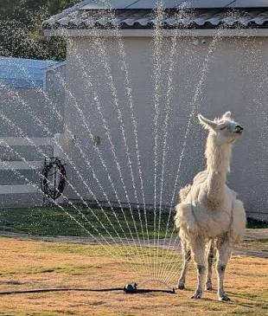 | LANA Board of Directors Meeting  June 18, 2026  Minutes
Present: Margaret Drew, Emily Muirhead, Kathy Nichols, Joy Pedroni, and Stephanie Pedroni
Absent: Eileen Ditsler, Susan Rich, Cali Roberson, and Cathy Spalding
 | Call to order and review of the agenda President Kathy called the meeting to order at 7:05 PM. In the absence of the secretary, Vice President Stephanie Pedroni took the minutes for the meeting.
Past meeting minutes
Approval of May 21, 2026 minutes: Steph moved to approve the minutes as written and Emily seconded. The motion passed unanimously.
Treasurer’s Report
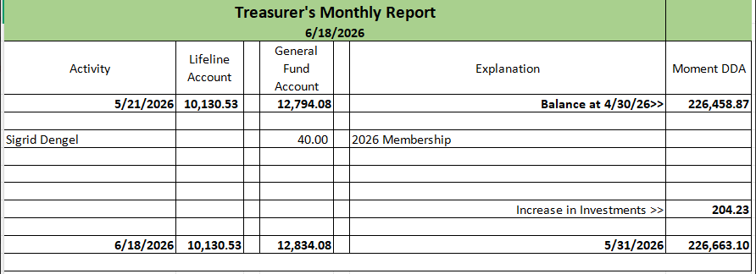
Treasurer’s Report: The above report was emailed to BOD’s prior to the meeting. Joy reported that there was a $40 membership that was deposited to the General Fund.
LANA Website: Joy has updated the art and writing information, the calendar, and the minutes page. She needs to add the newest newsletter.
Secretary’s Report
- Communication:
  - Youth medallions mailed to Knuckles and Amanda Wicjk
  - Package of 3 llama figures mailed to 4H group
  - Reordered 500 LANA cards
- LANA Email request from Kids Cancer Connection: Joy reported on a contact she had with an organization hoping to set up a llama/alpaca adoption experience for children with cancer. The outreach came from a non-profit that supports and tries to brighten child cancer patients. They are interested in "adopting" a llama/alpaca. We would send bio’s, pictures, stickers, in some sort of a care package. An adopter would send an email and the owner could send communication and pictures if their llama was “adopted.” The Board decided to start with board members and see how it goes, then expand to LANA members, if successful. Perhaps an in-person visit might be possible. There has been no discussion about the number of children who might participate. Joy moved we reach out and get involved, and Margaret seconded the motion which passed unanimously. The board suggested that Sue spearhead the effort, and Joy will assist as needed.
- 2026 LANA Membership Update: Joy reported four new members, one of which was a Friends of LANA (FOL) for $250.
Social Media “Campaign” – Caption This Update:
It was reported that LANA BOD members have been locked out of Instagram yet. Emily reported that she has reached out to get us unlocked and once she's back in, she will change the email contact to be the LANA address instead of her personal one. There has been a lot of engagement via Facebook. In regard to frequency of posting, the first two were approximately 3 weeks apart. This feels like a good pace. Board members are encouraged to add reactions & captions
Update on Potential Research Projects: Holding and Tabled
Llamping Update: Stephanie and Joy reported that no date has been chosen yet. They will bring a date to the next meeting so that the Board can begin to advertise and invite others.
State Fair: Plans and Discussion
Kathy reported that the entries close the 24th and the numbers are low so far. Trailers will not be parked in the Z Lot this year; they will be in "secured parking in the horse barn area. " This is very good news, especially for those who were negatively impacted last year. This information should be eblasted as it may impact folks’ interest in coming or not.
Fiber Clinic Plans
Margaret provided some potential dates: August 15/16, 22/23 or 29/30. She also offered that she could do a pop up/flash date & do more than one.
Youth Medallions:
New Recipients:
- Knuckles awarded one at Estes Park
- Amanda Wick has one for upcoming Glacier Show
- Nick Hauptley awarded one, waiting on full write up and picture from Nick
  - He used 3 secret judges vs. the show judge
  - The Show Judge is busy and focused on what's happing inside the ring
  - The award should really be based more on what's happening outside the ring
  - Superintendent has the final call on how to do this, but let's suggest this
Added Agenda Item: Local Outreach Llama PR Opportunities
Stephanie reported that she was inspired by how much Lee does with his local community. The Board should watch for opportunities for outreach. 4H groups often set up in front of Tractor Supply locations. There's one opening in Vacaville; maybe we can be a part of their Grand Opening. Steph will contact the Dixon store to inquire and maybe do something there too. Additionally, there are opportunities at libraries and nursing homes. The Board expressed interest in these endeavors and want to keep talking about it as a board.
Continued Show Sponsorship Discussions: tabled
Newsletter: President Kathy reported on the following:
- Upcoming Events: American River Cleanup, Fiber clinic date, and searching for local outreach opportunities
- Waiting on article for a ranch highlight
Request for agenda items for next meeting
- Llama PR
- Youth medallion recipients
- State Fair numbers
- Fiber clinic date update
- Llamping date update
- Sponsoring Regionals – a discussion
- Local outreach opportunities
Date for next conference call meeting at 7 PM:
Next meeting: July 16
Additional meetings in 2026: August 20, September 17, October 15, November 19, December 17
Adjournment: President Kathy adjourned the meeting at 8:05 PM.

