Fiber  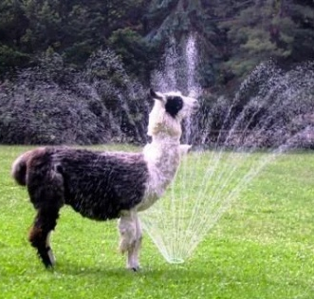 | LANA Board of Directors Meeting  August 21, 2025  Minutes
 | Present: Lee Beringsmith, Margaret Drew, Emily Muirhead, Kathy Nichols, Joy Pedroni, Stephanie Pedroni, Susan Rich, Cali Roberson, and Cathy Spalding
 | Call to order and review of the agenda: President Kathy called the meeting to order at 6:34 PM. There were no requests to amend the agenda.
Past meeting minutes
Approval of July 17, 2025 minutes: Joy moved to approve the minutes as written, and Lee seconded the motion. The motion passed unanimously.
Treasurer’s Report
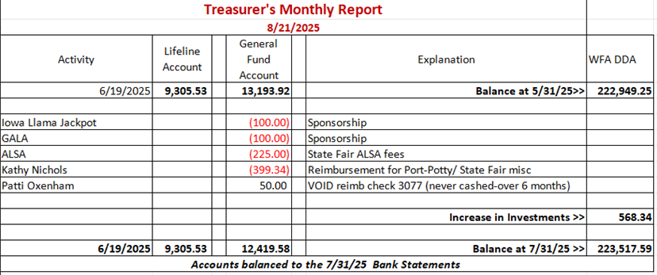
Joy reviewed the budget above. Our savings account has accrued $568+ in earnings.
LANA Website: Joy has done some updates, but she has edits to make on membership. She is working on a new slide show of various shows. She should be able to make updates tomorrow. Lee has provided a flyer for the American River Clean Up. Joy will post this. Kathy requested that the Youth Medallion Awards be added.
Secretary’s Report
- Communication: Sue reported that she had not sent out any letters or cards.
- Update on 2 Flaming Star pack systems for donation: Too Late. Sue reported that she reached out to the donor but he had already “disposed” of them. Joy indicated that she might have another donation of a pack that she can bring to Hobo.
Response from GALA Conference regarding sponsorship: Joy indicated that she had sent the check for the ¼ page ad. She has not heard anything back.
The Great American River Clean Up: Lee has provided an invitation for eBlasting. The event is 9 – 12 noon on Sept. 20th. It is a good PR opportunity. Sue will eBlast the invitation. Lee indicated it as a beautiful site, a wilderness in the middle of a large city. It is a unique setting.
Potential Research Projects:
- North West Camelid Foundation (Research Group) – attending? Due to the length of time and the budget impact, no LANA member will attend. Joy indicated that LANA was interested in connecting with the right people to discuss possibilities, and she is awaiting a response.
- Possibility of research regarding shorn skin issues: flies, sunburn, shear burns, etc. This is the outcome of an informal conversation at State Fair. This would be an in-depth effort but it would be very beneficial. No concrete next steps were identified.
State Fair Debrief: Even though the arena was smaller, it was a doable space. The movement of the bleachers was designed to draw more attention to the action in the ring. We had 31 halter entries, which was down from lasts year and 101 performance entries, which was also down. There were 11 youth showing – the same as last year. There were 37 animals and 5 shorn fleeces. Kathy read a card from the judge with kudos for the organization and flow of the show. A returning exhibitor texted Kathy with lots of photos and thanked Kathy for the welcome and support of the fellow exhibitors. The volunteers provided plenty of help. Kathy thanked the LANA Board members who ran the evening events. Kathy received donations from Evelyn Zatzke and a tub from the Katzakians with donations as well. These can be used at Hobo or Kids & Camelids. Sue will send thank you’s. Kathy received kudos for her organization, and the LANA team + Kayla really stepped up. Kathy appreciated the extra help in setting up the obstacles on Saturday morning.
Newsletter: Due to the 25 megabyte limit, the State Fair newsletter is in three volumes.
LANA BOD Parking Lot
- Walt Schaff’s Cart: This has been handled. He is happy that they will be used.
- Hobo Show Venue Updates: Joy and Kathy need to check out a new venue. They will coordinate with Cali.
- Ordering of Youth Medallions – as part of Hobo Show ribbon order. Joy looked through all the possible medallions. It is a 2-3/4” diameter and comes in gold, silver, bronze. We can put our logo on the front and up to four lines on the back. We have a choice of ribbons. For 15, we can spend about $45. Joy can order the medallions with the Hobo ribbons.
- LANA’s Vision: how best to serve the camelid community Tabled
- Help to other Llama/Alpaca 4H Projects Tabled
- Continued discussion re LANA merchandise Tabled
Request for agenda items for next meeting Tabled
Date for next conference call meeting at 6:30 PM:
Next meeting: September 18
Remainder of 2025 meetings: Oct. 16, Nov 20, Dec 18
Adjournment: Kathy adjourned the meeting at 7:26 PM

