Fiber  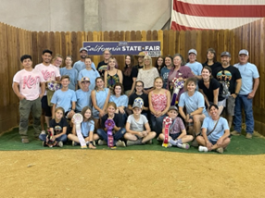  TO DO LIST:  Joy: back up the newsletter editions  Kathy: cash reimbursement check  Stephanie: investigate the organization requesting support of its T shirt sale  ALL: change your calendars for the American River Clean Up - is is scheduled for Sept. 23  Sue: send out a poll regarding best date for a Felting Clinic  Joy: reach out to 4H projects to inquire about additional spport to groups  Margaret and Joy: reach out to Dr. Mora to discuss the possibility of a Dental Day | LANA Board of Directors Meeting  August 17, 2023  Minutes
Present: Margaret Drew, Kathy Nichols, Joy Pedroni, Stephanie Pedroni, Rondi Smith
Absent: Lee Beringsmith, Emily Muirhead, Susan Rich, and Cathy Spalding
 | Call to order and review of the agenda: President Kathy called the meeting to order at 6:34 PM. In the review of the agenda, Kathy requested to continue the discussion of a Dental Day, and this was added. Noted: in Secretary Susan Rich’s absence, Stephanie Pedroni took the minutes.
Past meeting minutes
Approval of Jully 20, 2023 minutes: Rondi moved to approve the minutes as written, and Stephanie seconded the motion. The minutes were approved unanimously.
Review of “To Do List”: In the review, it was noted that Joy still needs to back up the newsletter editions to store them in the cloud.
Treasurer’s Report 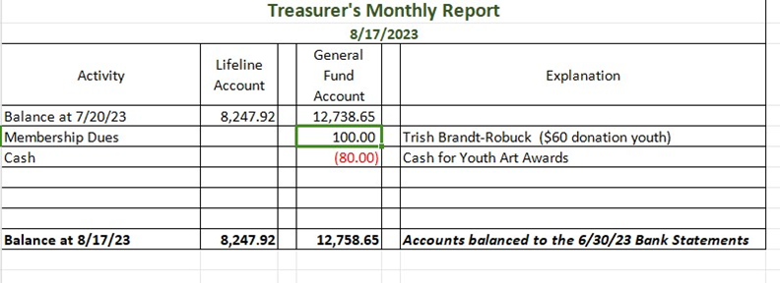
Joy reviewed the report previously emailed and posted above. She added that she has just received a $25 check for advertising in the newsletter. Kathy indicated that she had a reimbursement check for the exhibitor’s chair she will cash.
Secretary’s Report
- Correspondence & LANA email’s inbox: Sue had emailed a Secretary’s report prior to the meeting that was discussed.
- A thought about the request to plug the sale of T shirts:
  - A potential article from an out-of-state source? (Broaden LANA?) The Board opted to investigate the organization requesting the promotion of its llama themed T shirt in order to avoid any possible scams and then decide whether to support or not. Stephanie volunteered to investigate. Perhaps a Facebook post instead of an eBlast would be best. If the Board opts to move forward, then we can investigate the option of an article for the newsletter.
 | State Fair: Debrief There were 56 animals in attendance, which was up a few from last year. There were 33 more entries this year than last. The performance day was long: 9:30 AM – 9:30 PM, with an hour lunch break. Barn personnel were at the roll down doors right at closing this year and were notifying people that the barns
were closed, and this was very much appreciated. All the results have been sent to ALSA and staff there is working on posting them to the ALSA website.
Two New LANA Play Days: August 26 and Sept. 9 These two dates were chosen based on availability of interested parties. Please note the same conditions for past play days are true for these: arrive and depart on your own schedule, bring your own food and drink, $5 per person.
Newsletter The State Fair edition is ready to go. Kathy is just waiting to hear from the Merced Fairgrounds staff regarding details for the 2024 Hobo Show. Kathy is already working on the next edition.
How can we broaden LANA to North America?
Expanding Social Media outreach: Updates
The Board was enthusiastic about using social media to promote and advertise any shows or LANA events in the future. There was discussion about posting other events such as National Donut Day and Back to School, etc. How can LANA encourage others to post and tag us?
Continued Discussion of Other Possible Activities/Parking Lot
- YouTube Channel w/ video clips: a curated list?
- Community Service Project: American River Clean up – Sept. 16 Note: there is a change of date; mark your calendars for Sept. 23rd
- Felting Clinic? Margaret is happy to host. September 2nd or November 4th. The suggestion was made to poll via an eBlast and to prioritize the responses of the LANA membership.
- Help to other Llama 4H Projects: At the next Play Day, let’s have a conversation with Denise Jones (from El Dorado) and Sarah Mattia (Miners’ Ravine). Can we support them at other fairs? Some groups at State Fair were interested in expanding their alpaca project to include llamas. Rondi noted that Washington is starting a llama group in October. Joy will reach out to other 4H projects to inquire.
- Added agenda item – Dental Day: Dan Mora is the vet who specializes in dental work on camelids,. He is expensive but he is the expert. We can split the ranch call and make it an opportunity to have dental work done. He can take care of fighting teeth and show how that is done. He can work on lower overbites. He can also talk about what to look for and when to make an appointment. How about the spring? Margaret has a barn so we can take weather out of the equation. Margaret and Joy will reach out to Dr. Mora.
Request for agenda items for next meeting
- Debrief on Play Days
- Update on a Dental Day
- Update/debrief on a Felting Date
- American River Clean UP
- Support of 4H groups
Date for next conference call meeting:
Next meeting: Sept. 21
Future meetings: Oct. 19, Nov. 16, Dec. 21
Adjournment: President Kathy adjourned the meeting at 7:20 PM

