Fiber  TO DO LIST:  Sue: eBlast out the opportunity to run for the Board to 2023 LANA members  Stephanie & Kathy: email candidate statements to Sue by Nov. 30 if interested in re-running for directorship  Sue: revise the Youth Writing and Art contest for Nov. LANA meeting for review  Sue: email reminder to those signed up for the Felting Clinic on Nov. 4 w/ specifics re time and potluck  ALL: Book March 24th as “An Afternoon with George”  ALL: Book May 11th as a Dental Day/Shearing Clinic with two stations at two Vacaville ranches  Sue: eBlast the 2024 membership form late November to early December  Emily: begin to curate videos of llama/alpaca related things  Emily: send the Instagram log in to Stephanie | LANA Board of Directors Meeting  October 19, 2023  Minutes
Present: Lee Beringsmith, Margaret Drew, Emily Muirhead, Kathy Nichols, Joy Pedroni, Stephanie Pedroni, Susan Rich, and Rondi Smith.
Absent: Cathy Spalding
Sidenote: Rondi did a shout out for Margaret who judged a show for her kids.
 | Call to order and review of the agenda: President Kathy opened the meeting at 6:32 PM. There were no requests to amend the agenda.
Past meeting minutes
Approval of September 21, 2023 minutes: Joy moved to accept the minutes as written. Lee seconded the motion. The motion passed unanimously.
Review of “To Do List”: The BOD silently checked the list and no comments were made.
Treasurer’s Report
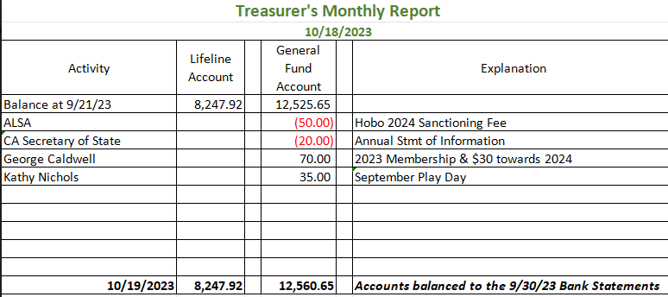
Joy reported that she has completed the 2023 CA Secretary of State required Statement of Information and the 2022-2023 Federal and State Income Taxes and submitted them. The year ended on September 30, 2023. Other than the upcoming Fiber Clinic, she does not expect any expenses in the near future.
Secretary’s Report
- Correspondence & LANA email’s inbox: There was nothing mailed from LANA this month. Sue shared the RMLA email indicating that the UN had declared 2024 as the Year of the Camelid. There was some discussion how we might use that moving forward.
 | American River Clean Up Debrief: Lee indicated that there was larger turnout than he expected. Everyone started out in the parking lot and dispersed to pick up trash. There was a variety of “bring backs” from their treks. Cali Roberson wrote up the event for the LANA newsletter. There are lots of photos.
 | Blessing of the Animals Debrief: Sue took two llamas to a Blessing of the Animals at a nearby church. It was a great PR moment, and the animals behaved well with all the distractions. Joy mentioned the opportunity to take an animal to a screening of Napolean Dynamite in Campbell. She will let us know how it goes.
Board terms and upcoming elections: Stephanie and Kathy come to the end of their terms at the end of this calendar year. If interested in running again, candidate statements are due to Sue on November 30. Sue will eBlast out the opportunity for LANA members to run for office.
Youth Art and Writing Awards: categories and descriptors: The message shared via LANA eBlast will stand for this November 1st deadline for youth submissions. Board reviewed the language and practices of the contest. The Board decided to broaden the opportunities for youth in regard to both writing an artwork. Sue will rewrite the Youth Contest language and bring it to the next LANA BOD meeting.
Felting Clinic: Nov. 4: There are lots of participants already signed up. Margaret and her friend will be dying extra rovings for the group’s use. She has a neighbor coming to set up the tables. And the barn is available in case of rain. Sue will send out a reminder to those who have signed up with a 9 AM arrival with a 10 Am start. The reminder will include that this is a potluck.
“An Afternoon with George”: The Board discussed possible calendar slots for this afternoon at Llamas of Circle Home at George and Christine Caldwell’s place. The Board penciled in March, the 23rd. Sue will check his website to see what he still offers. Food will be something that people can bring for themselves. Cooler of water might be something LANA could bring. The event will billed as: Bring your own picnic. Bring your own chairs. And it will be a free event for everyone.
Dental Day: Margaret reached out to Dr. Danny Mora, DVM, who is available any Saturday. He is a specialist, and he has a following in various parts of the country. There will be a ranch call fee. He works with alpaca and llamas. He corrects the animal’s bite, and he guides the teeth to continue to grow in the appropriate direction. Margaret indicated that she has videos of his work at her ranch from the past. Margaret will reach out to him to ask about how many animals he might be able to do in one day. He lives about 30 minutes from Vacaville. Perhaps we could set up stations: shearing at Joy’s and teeth at Margaret’s. Perhaps May 11th? (about the time we scheduled this last year).
Prepping for Membership Drive: 2024 – The Board would like to keep membership prices the same. Sue can eBlast the new membership form mid-November to the first part of December.
Newsletter: The Fall newsletter is pretty much set. Kathy is waiting for the results of the Youth Writing and Art Contest to include those. And she will include the Fiber Clinic – both a write up and the photos before it goes out. Sue shared that she has interviewed the gentleman from Not Forgotten Outreach. Joy and Stephanie owe an article. Kathy reached out to a youth doing public relations with her llama in Indiana. The young lady agreed to write an article for the newsletter.
How can we broaden LANA to North America?
Expanding Social Media outreach: Updates
- Curated list of YouTube video clips? Emily is looking for videos on shearing and fiber quality. And the breadth of issues is just all things llama and alpaca. Perhaps Kathy could include the links as they are being curated in the newsletter as Joy posts them on the website.
- NationalDaycalendar.com is a resource available out there. One day was “I Love Yarn” – Eileen set up a photo of all her yarn. National Sports Day was another day – and she included a photo of Lola and her “goal” llama. She is getting some responses on Facebook. Stephanie is sending things to Emily. Stephanie asked Emily for the log in for the Instagram account so Stephanie can log on too.
- December 9 is National Llama Day!! Photo contest? Slide show on facebook? An album? A due date of December 1 would work.
Continued Discussion of Other Possible Activities/Parking Lot
- Help to other Llama 4H Projects: As Joy has reached out, they have loved the Play Days and hope we will continue to put them on. Is there a way to get contact information for all llama/alpaca 4H projects in the state?
- Morris Animal Foundation meeting: Tabled
- UN declaration of 2024 as the Year of the Camelid: a campaign. Perhaps we could feature a ranch a month throughout the year.
Request for agenda items for next meeting:
- Hobo Show
- Usual standing agenda items
Date for next conference call meeting:
Next meeting: Nov. 16
Future meetings: Dec. 21 For 2024 – hold the same day/time? We will keep the third Wednesday of the month as standing appointment for the LANA BOD meetings.
Adjournment: President Kathy adjourned the meeting at 7:57 PM

