Fiber  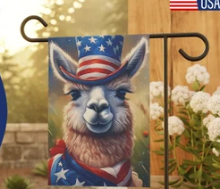 | LANA Board of Directors Meeting  May 15, 2025  Minutes
Present: Margaret Drew, Emily Muirhead, Kathy Nichols, Joy Pedroni, Stephanie Pedroni, Susan Rich, and Cali Roberson
Absent: Lee Beringsmith and Cathy Spalding
Call to order and review of the agenda: President Kathy called the meeting to order at 6:35 PM. Sue indicated that both Cathy Spalding and Lee Beringsmith were unable to join the meeting, and that Lee gave his proxy to Susan Rich. There were no requests to revise the agenda.
Past meeting minutes
Approval of April 17, 2025 minutes: Stephanie moved to approve the minutes with the correction of a typo, and Emily seconded the motion. The motion passed unanimously.
Treasurer’s Report
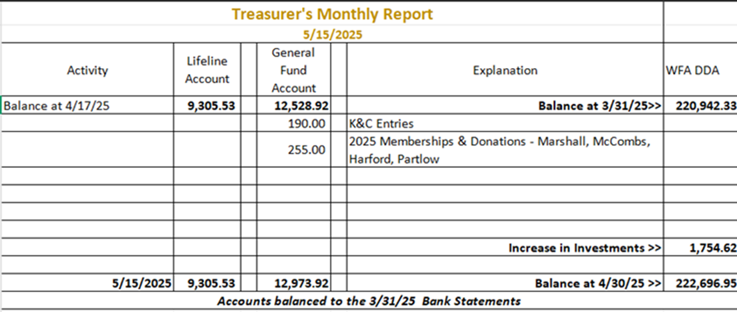
Joy sent a budget to the Board in advance of the meeting, and it is posted above. Sue read Joy’s report as she was enroute during this portion of the meeting. Joy and Kathy were sent paperwork to sign acknowledging that the Hitchcock group at Wells Fargo is now the Moment Partners, as managers of the WFA DDA fund.
LANA Website: Joy indicated she needs to add the new memberships to the website and the new dates for events. Sue will send Joy a new flyer and new Show Summary form. Joy needs photos from the Butte Hike to remove the Year of the Camelid banner. Cali will send her the photos. Stephanie indicated she would send photos from the Davis Vet event.
Secretary’s Report
- Communication: 7 LANA membership forms were mailed as per last month’s Board discussion, 3 thank you’s for membership were mailed, and 1 packet w/ Youth Medalion was mailed to Margaret to take to a show she is judging in the near future.
- LANA Notecard & NOK cards update: Sue indicated she had the artwork provided by Cali in at the printers, and she ordered 100 notecards. These will have the LANA Mission Statement on the back of the card, at no extra cost. Additionally, she ordered 200 of the Next of Kin (NOK) cards. She plans to distribute the first set at the Kids & Camelids Show, and then use them in the thank you cards for 2026 membership
2025 Membership Drive:
Memberships to date: 34 Friends of LANA (FOL): 2
Ranch memberships: 30 Club Memberships: 1
Youth Memberships: 3 “Gifted” memberships: 5
Sue updated the numbers based on new additions, and Joy indicated she would search for additional membership forms.
Walt Schaff’s cart: Margaret sent a letter and has not heard back. She will continue to try.
Potential Research Project – Updates
Question: Principle? Sue moved to establish $150,000 as the principle and Margaret seconded the motion. The motion passed unanimously. Margaret wondered how we could protect these funds to ensure that they are spent as they were historically meant to be expended. An upcoming LANA newsletter article is being written to preserve the history of these funds. The Board’s responsibility is to maintain the focus. Perhaps we should amend our bylaws to have language around these funds in an official document.
Updates on proposals: Stephanie sent a few emails as per our conversation. She has had no replies as of yet.
Hobo Show: Potential New Venue: Sue reported that she had a conversation with a gentleman regarding the use of Modesto Junior College’s Ag Pavilion. She shared that access to the facility is by priority: 1st – school’s programs and clubs, 2nd agencies which have a sponsor on campus, and lastly the public. He shared that many events roll over annually that fit into the first two priority groups, and that Hobo’s time of year have every weekend booked typically. The summer has more options. Joy will investigate a site in Corning. There is hotel and RV park right there. She may also look at something in Red Bluff. She and Cali might go back to see the Ceres site to look it over.
Kids & Camelids - Yet another new date: June 14 Sue reviewed the list of youth who indicated they could attend on June 14th from the poll taken of the youth. June 14th is the new date. There is no new information to share.
Youth Medallions
- Update: Kathy has photos of the LANA Youth Medallion being awarded at the Imaginology Show. Show staff didn’t present one at LA County, as they just didn’t get to it. There was discussion about having Margaret take a medallion to the OFFF: Oregon Flock and Fiber Festival in Albany, Oregon, on October 18 and 19th. There are youth and special needs groups there.
- Ordering new medallions? The medallions came from the Hodges Badge Company. Kathy indicated that they no longer carry the same medallions. Perhaps we should order at the same time as we order the Hobo ribbons to get a discount which covers the shipping. We should look at the new options at the next LANA Meeting.
State Fair Updates: Kathy put an announcement on Facebook. The deadline is June 18th. Kathy will be asking Board members who attend State Fair for assistance with evening events
Newsletter: The Knuckles will be sending an article about their ranch as part of Kathy’s efforts to showcase ranches of members outside of California. There is a research article in play. Joy and Margaret need to submit an article on SAMVA. Sue can add to her article about research the recent decision of the Board to keep the principle at $150,000.
LANA BOD Parking Lot Tabled for the most part
- LANA’s Vision: how best to serve the camelid community: Kathy would like to investigate the possibility of a joint venture with CALPaca.
- Help to other Llama/Alpaca 4H Projects
- Continued discussion re LANA merchandise
Request for agenda items for next meeting Tabled
Date for next conference call meeting at 6:30 PM:
Next meeting: June 19
Remainder of 2025 meetings: July 17, Aug 21, Sept 18, Oct. 16, Nov 20, Dec 18
Adjournment: President Kathy adjourned the meeting at 7:37 PM.

