F  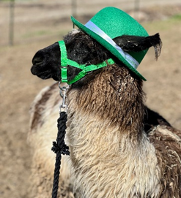  TO DO LIST:  Sue: connect w/ MAF to let them know we are planning to keep research funds with them and ask about fees  Joy: connect w/ ALSA office to send check for CA State Fair sanctioning  Sue: write about the upcoming 4H field trip for the newsletter  Joy: write an update on Larry Not A Llama for the newsletter  Joy: send links to CalPACA to Rondi  Rondi: submit requests for rescue support to CalPACA and LANA’s Lama Lifeline being sure to provide specifics  Joy: create a flyer for the Shearing Clinic and share it with Sue for an eBlast  Joy & Margaret: field test the felting project Kathy shared from TikTok | LANA Board of Directors Meeting  March 16, 2023  Minutes
Present: Margaret Drew, Kathy Nichols, Joy Pedroni, Stephanie Pedroni, Susan Rich, Rondi Smith, and Cathy Spalding
Absent: Lee Beringsmith and Emily Muirhead
 | Call to order and review of the agenda: President Kathy called the meeting to order at 6:33 PM. Kathy requested that we add CA State Fair to the agenda. Rondi Smith asked that we add an agenda item about the protocol for requesting funds from LANA’s Lama Lifeline.
Past meeting minutes
Approval of February 2023 minutes: Joy moved to approve the minutes, and Stephanie seconded. The motion passed unanimously.
Review of “To Do List”: Kathy indicated that the RMLA sent out an eBlast in regard to the sale in response to the request we received in the LANA gmail account.
Treasurer’s Report
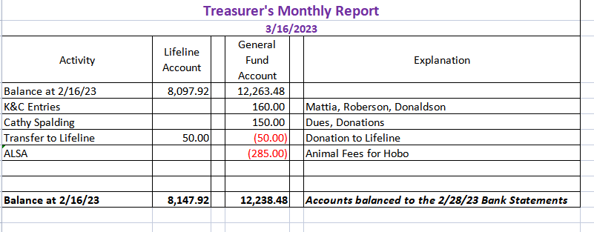
Joy reviewed the Treasurer’s Report that she had emailed previous to the meeting and that is provided above. There has not been much activity. Cathy Spalding made some donations in addition to re-upping her membership. Kathy indicated that she did not receive her reimbursement check.
Secretary’s Report
- Correspondence: Susan shared that she had written 6 thank you notes, with stickers, to those who had re-upped their 2023 LANA membership. Additionally, she sent a hard copy of the LANA membership form/membership and donation options to the 10 people Kathy Nichols had identified. Additionally, she emailed two others with the same. She emailed the flyer and the Show Summary form for the upcoming Kids & Camelids Show to all previous participants.
- LANA email’s inbox: Susan shared an email from a member trying to use PayPal, and the recent eBlast that went out to membership celebrating St. Patrick’s Day.
2023 LANA Membership Drive
- Numbers to date: 25. A last minute addition to membership took the number from 25 to 26.
- Continued discussion about possible outreach re membership: Joy shared that she had a conversation with a llama enthusiast with children who was close to Lake Oroville who was interested in membership and the Kids & Camelids Show. There are some potential membership there.
Update on funds held by the Morris Animal Foundation
- Update on discussion w/ Dr. Dechant: Joy shared that with the MAF backing out, there is a void in camelid research, especially in regard to llamas. There are two organizations trying to manage research projects, and it appears that oversight very, very hard. She believes it is our best option to affiliate with AASRP: American Association of Small Ruminant Practioneers. Our best option with funding is to leave it with MAF. Q: Would they be willing to put out an RFP around a topic we provided? A: Unsure. Perhaps. Dr. Dechant is in communication with this group. So, we hold to see what develops out of this. Stephanie felt very optimistic about this potential option. Kathy concurred. The potential to cooperate with other groups is out there too. Joy will let us know how this discussion unfolds by staying in communication with Dr. Dechant.
- Update on MAF correspondence: If we leave our money with the MAF, there would likely be a negotiated fee. Sue will let the MAF know about the decision to keep funds there and then ask more specific info about fees to be charged.
How can we broaden LANA to North America?
Expanding Social Media outreach: Updates Stephanie liked what we have put out so far. And we have gotten some positive responses. This discussion was embedded in the planning for the Shearing Clinic.
CA State Fair: The show is sanctioned and on the ALSA website. Joy will be sending a check when she is able to connect with the ALSA office staffer. Tracy Weaver is the judge. The handbook has been updated and sent in and a schedule. There are changes around the premiere youth exhibitor. Prior, youth judging was a part, but that hasn’t taken place in a while.
Newsletter: Stephanie will write an article and share photos from the Hike on April 1st. Kathy needs one more new article. We have a 50 page limit on the newsletter, and that is why the Hobo Show newsletter was in two parts. She will have to go back and split any older issues over 50 pages or we cannot open it . Joy will provide an update on Larry not a Llama who is now officially housed with a small herd. Sue offered to write up something on the upcoming field trip to the Labendeira Ranch.
LANA Lifeline protocols: Rondi shared information about an upcoming alpaca rescue in the Mojave Desert of 45 alpacas. They hope to take care of all the needs in three days. Once treated, she will spearhead efforts to adopt them out. She will be trailering the males to UC Davis to have them castrated. Rondi will trailer any unadopted alpaca back to her place. She believes that the owner will be providing $3,000, but shearing alone is expected to be $2,000. Funds should also come in from adoptions. Joy shared that contact with Jerry Kimbro is the way to start to the process of requesting Lifeline funds. Cathy shared that the request needs to be very specific: outlining the emergency and then specifying what funds are needed for. If the Lifeline committee approves of funds, Joy is told to cut a check as per their direction. It was suggested that Rondi also contact CalPACA for assistance. Joy offered to provide links.
Llamping Plans: Joy has been in contact with the facilities. She completed forms and reserved spaces 1 – 8. She has not yet received the paperwork. There has been so much water, the lakeside trails might be really wet or even underwater. Joy will continue to share information as she gets it.
Kids & Camelids: April 22, 2023
Registrations to date: 3 families have registered so far.
Plans and Ideas: Kathy shared that we will need the delivery of a Port-a-Potty. If we have another event, we could leave it on the place. The cost is in the delivery and pick up. People liked the play days. Kathy has an idea for an art project for the kids and has been preparing for it. Sue commended Kathy for allowing a new junior exhibitor to use Kathy’s llama for the show.
Shearing Clinic
Final Date: Saturday, May 13th. Margaret is hosting at her home.
Plans: Joy is working on a flyer, and once it is done, Sue can eBlast it out. Can we include the skirting of a fleece demo with this Clinic? Can we film pieces of this for posting? Margaret: yes, because skirting starts with the shearing. And yes, we could video tape it. It is very specialized. Stephanie shared that we would really need to plan out who is doing what. Rondi offered to help. She is aware of software that allows for “overtalk” and addition of music and options to cut and paste. She can help us establish a YouTube channel as well. It can be posted across various platforms.
Continued Discussion of Other Possible Activities/Parking Lot
- YouTube Channel w/ video clips (incorporated into the discussion about the Shearing Clinic)
- Fundraising ideas for LAMA Lifeline Tabled
- Other possible events: Demo for skirting a fleece? (incorporated into the discussion about the Shearing Clinic)
- Community Service Project: American River Clean up – Sept. 16 Tabled
- Felting Clinic: Kathy saw a felting project on TikTok, and she shared it with Joy and Margaret. They are going to pilot the process and see if they want incorporate it into the Felting Clinic. Rondi shared that she makes kits available to kids to purchase after a clinic to take home a project. She charges about $25 apiece. Needle felting is also something they wanted to try this time.
Request for agenda items for next meeting
- Kids & Camelids
- Shearing Clinic
- Hiking the Buttes debrief
Date for next conference call meeting:
Next meeting: April 19, 6:30 PM (Note: a Wednesday evening!!)
Future meetings: May 25, June 15, July 20, Aug. 17, Sept. 21, Oct. 19, Nov. 16, Dec. 21
Adjournment: President Kathy adjourned the meeting at 7:42 PM.

