Fiber  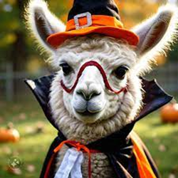 | LANA Board of Directors Meeting  October 23, 2025  Minutes
Present: Lee Beringsmith, Margaret Drew, Emily Muirhead, Kathy Nichols, Joy Pedroni, Stephanie Pedroni, Susan Rich, and Cathy Spalding
Absent: Cali Roberson
 | Call to order and review of the agenda: President Kathy called the meeting to order at 6:32 PM. There were no requests to amend the agenda.
Past meeting minutes
Approval of September 18, 2025 minutes: Stephanie moved to approve the minutes as written. Margaret seconded the motion. The motion passed unanimously.
Review of the To Do List: Kathy indicated that she still needed to reach out to UC Davis regarding research. Terming Board members need to submit their candidate statements.
Treasurer’s Report

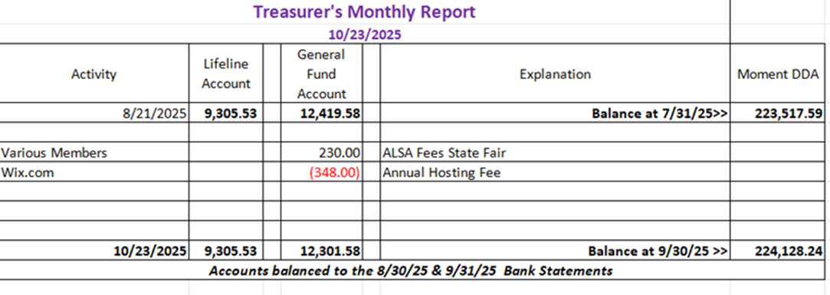

Treasurer Joy Pedroni had forwarded the Report above to the Board prior to the meeting and she reviewed it. The General Account ended at over $12,000. The Lifeline account is unchanged. Our invested research funds started with a $213K deposit and now sits at $224K and change. Sept 30 is the fiscal year end, and Joy has completed the state and federal tax preparation.
LANA Website: Joy put the Fiber Clinic flyer on the main page of the website.
Secretary’s Report
- Communication:
  - Youth Medallion was mailed to the Regionals awardee
  - A Camelid Neo-Natal Clinic flyer was eBlasted
- Gearing up for Membership Drive 2026
Revised membership form: Final edits to the 2026 membership form were made via discussion. Sue will create a final copy and email it to the Board, for Joy to post on the website and for Kathy to include in upcoming newsletters.
- Submission for LANA Youth Writing Contest
Slight revisions to the flyer, adding age of submitter: Sue made a slight edit to the LANA Youth Writing Contest to ask for the name and now age of the submitter to ensure that the submission was entered into the right category. Additionally, she noted that she had one senior writing submission come via the LANA Website. Board member Cali Roberson also submitted a junior art piece on behalf of her daughter. Sue will send that submission out to the Board
Hobo Show Updates:
- January 30 – Feb. 1, 2026
- Ceres Venue booked: Kathy and Cali visited the arena and booked it with the owner. Kathy had provided an email prior to the meeting with photos. There is an outside obstacle course that would be great for the pack class, if the weather permits. There is the potential for a Short Stack: this is a pack obstacle class with one animal attached to a lead animal. Kathy believes that the water faucets are pretty far from the stalls. We should mention that in the flyer if that is the case. We would not use the outdoor stalls at all. Kathy thinks 2 big llamas will fit per stall. There is lots of room for self-penning. The owner indicated he would pack down the arena prior to the show so it will be smooth and level. The owner hoped that this might be an annual event.
- Other considerations:
  - Annual Awards: Sue will send out the categories for the Board members to read over while considering whom to nominate at the next meeting.
  - Saturday Night Dinner: There is an outside grill and smoker and a full kitchen available for the cook. Stephanie will check on a possibility.
  - A Hold the Date Flyer: Stephanie volunteered to put together a flyer to advertise the new location. Kathy will send Stephanie some pictures.
Potential Research Projects:
Update on outreach efforts: Stephanie reported that Kathy uncovered, via Barb Baker from GALA, that there were two promising research proposals. Stephanie drafted and emailed a solicitation letter which the Board reviewed. Stephanie wondered to whom we should reach out. Cathy Spalding made some suggestions. Joy suggested that we keep Dr. Dechant of UCD in the loop. Kathy had referenced a vet at Colorado State. Stephanie will tailor the draft letter and send it out, and keep the Board posted about responses. We will keep this as a standing agenda item.
Fall Fiber Clinic: November 1 The flyer is on the website and has been eBlasted out. Joy offered her place as a Plan B if Margaret needs assistance. The event is a potluck. Some have already expressed interest.
Newsletter: Kathy needs a ranch article. She has a few articles in the making. If she can keep it under 20 megabytes, it can go as a one attachment send. This edition is in the early stages.
Board Member Terms: This is a reminder for Candidate Statements. Sue will email LANA members about the possibility of becoming a Board member.
LANA BOD Parking Lot
- Ordering of Youth Medallions – as part of Hobo Show ribbon order. Joy and Kathy will put together a ballot with multiple options for Board vote.
- LANA’s Vision: how best to serve the camelid community Tabled
- Help to other Llama/Alpaca 4H Projects Tabled
- Continued discussion re LANA merchandise Tabled
- Added: Memory pieces of Greg Sykes and Dennie Hansen. Kathy will ask Greg’s daughter for a photo and info.
Request for agenda items for next meeting
- Research update
- Fiber clinic
- Youth Contest Submissions
- Annual Awards
- Hobo: Auction, etc.
Date for next conference call meeting at 6:30 PM:
Next meeting: November 20
Remainder of 2025 meetings: Dec 18
Adjournment: Kathy adjourned the meeting at 7:39 PM

